
NEXTGEN
FIELD TRAINING

Customized for Your PD
August 2026

Thin Blue Line of Leadership LLC ©

TABLE OF CONTENTS

- Program Overview…………………………….…………………………………………………………………………………… | 3
- Program Objectives…………….…………………………………………………………………………………………………. | 5
- Key Terms and Abbreviations…………………………………………………………………………………………........ | 7
- Field Training Officer Expectations – P.A.T.H…………………………………………………………………………. | 11
- Training Methodology……………………………………………………………………………………………………………. | 13
- P-R-I-D-E Adaptive Decision-Making Model………………………………………………………………… | 15
- Training Deliberate Action........……………………………………………………………………………....... | 18
- Officer Safety-Based Predictive Mindset......................................................................... | 19
- Policing Priorities………………………………………………………………………………………………………… | 21
- Standard Evaluation Guidelines……………………………………………………………………………………………… | 23
- CFS/Response Performance……………………………………………………………………………………….. | 24
- Self-Initiated Activity Performance……………………………………………………………………………… | 25
- Communication and Relationships.…………………………………………………………………………….. | 26
- Officer Safety Skills/Tactical Safety…………………………………………………………………………….. | 27
- Law Enforcement Decision-Making.……………………………………………………………………………. | 28
- Motor Vehicle Operations/Orientation………………………………………………………………………. | 29
- Standard Evaluation Guidelines Scoring Rubric.…………………………………………………………. | 30
- Discretionary Override.................................................................................................... | 31
- Program Structure…………………………………………………………………………………………………………………. | 33
- Training Phases…………………………………………………………………………………………………………… | 34
- Phase 1 - Training……………………………………………………………………………………………. | 35
- Phase 2 - Training……………………………………………………………………………………………. | 36
- Phase 3 - Training………………………………………………………………………………………....... | 37
- Evaluation Phases……………………………………………………………………………………………............. | 39
- Phase 4 - Evaluation……………………………………………………………………………………….. | 41
- Phase 5 - Evaluation……………………………………………………………………………………….. | 42
- Solo Phase - Evaluation…………………………………………………………………………………… | 43
- Field Training Workbook..……………………………………………………………………………………………………... | 45
- Exposure Forms………………………………………………….........................………………………………. | 47
- Proficiency Training Tasks…….……………………………………………………………………..…….......... | 49
- Self-Evaluation Form………………………………………………………………………….…………............... | 51
- Phase Expectations………………….…….………………………………………………………………….……….. | 53
- Phase Board Form………………………………………………………………………………………..…………….. | 55
- Release from Field Training Form………………………………………………………………….……………. | 57
- Daily Observation Reports………………………………………….…………………............……......................... | 59
- Training Phases…………………………………………..……………………..……………………………............ | 60
- Evaluation Phases……………………………………………………………………………………………............ | 65
- Field Training Program Sergeant Expectations…………………………………………..……………………........ | 71
- Extension Plans………………………………………………..………………………………………………………………....... | 73
- Performance Training Plans……….………………………….…………………………………………………………....... | 75
- Field Training Review Committee……………………………………………………………..………………………...... | 77
- Training Techniques…………………………………………………………………………………………....................... | 79
- Debriefing Options...................................................................................................................... | 83

PROGRAM OVERVIEW

How much has policing changed over just the last 5 years? How about the last 25 years? The last 50 years? The two most common models for field training used throughout the United States have been in use between 25 and 50 years. Law enforcement field training, either for lack of a better option or due to tradition, has failed to keep up with new philosophies in policing, improved instructing/learning strategies, and generational differences.

Over the years, many law enforcement agencies have customized these common field training models to bridge the gaps created by time and an ever-changing law enforcement environment. These adjustments and improvements have altered their original field training program to the point of being unrecognizable. As a result, the adjustments created many inconsistencies throughout the program. The purpose of the Nextgen Field Training Model is to bring field training better into alignment with 21st Century Policing ideals and current instruction/learning strategies. The time has come to hit the reset button and invest in a program that brings field training to the next generation of officers more efficiently and effectively.

The Nextgen Field Training Model is adaptable to any agency. Integrating the Nextgen Model starts with taking the time to reflect on your current field training program and answering four questions:
- What do you want to START doing that you aren’t already?
- What do you want to STOP doing that isn’t working for the users of your program?
- What do you want to CONTINUE doing that is working for the users of your program?
- What are you willing to CHANGE about your program to make it most beneficial to its users?



KEY CONCEPTS OF THE NEXTGEN FIELD TRAINING MODEL:

- Creates a distinct separation between TRAINING and EVALUATING for both FTOs and OITs.

  - There are three Training Phases and three Evaluation Phases.
    - Training Phases 1, 2, and 3 – No OIT Scoring of Observation Reports
      - FTOs work as a team to train the OIT how to do the job.
      - OITs must be trained in or exposed to all Proficiency Tasks before moving into the Evaluation Phases.
    - Evaluation Phases 4, 5, and Solo – OIT Scoring on Observation Reports
      - Phase 4 and 5 FTOs evaluate the OIT’s proficiency as a solo capable officer.
      - Both FTOs must agree the OIT is solo capable for them to proceed to the Solo Evaluation Phase.
      - Assigned patrol supervisor completes the Solo Evaluation Phase by observing if the OIT is solo capable while the OIT works on their squad without an FTO.

  - No scoring during Training Phases.
    - FTO evaluates through debriefs, documentation of OIT performance, and the training provided to the OIT; there just isn’t a score put to it.
    - Provides a training environment that encourages OIT effort and positive risk-taking.
    - Allows FTOs to focus on training and OITs to focus on learning.
    - Removes potential animosity between FTOs and OITs during training.

- Based upon a crawl-walk-run experiential learning philosophy for both training and evaluation.

- Emphasizes the Solo Capable Officer Standard – The goal is to create solo capable officers the FTOs want to work with when OITs are done with the program.

- Integrates the P-R-I-D-E Adaptive Decision-Making Model and Policing Priorities Training Methodology.

- Develops a clear framework for handling remedial training and probationary rejections.

- Much of the current terminology and technical aspects of common field training programs are consistent with the Nextgen Field Training Model to assist with familiarity during the transition.

TIMING OF NEXTGEN FIELD TRAINING MODEL:

- Phase 1: Training (Crawl) 4 weeks (Field Trainer 1)
- Phase 2: Training (Walk) 4 weeks (Field Trainer 2)
- Phase 3: Training (Run) 4 weeks (Field Trainer 3)
- Phase 4: Evaluation (Crawl) 2 weeks (Evaluator 1 – Field Trainer 1)
- Phase 5: Evaluation (Walk) 2 weeks (Evaluator 2 – Independent FTO)
- Solo Phase: Evaluation (Run) 4 weeks (Evaluator 3 – Assigned Supervisor)

- Extension Plan (As Needed) 1 or 2 weeks
- Performance Training Plan (As Needed) 2 weeks
PROGRAM OBJECTIVES

The objectives of the Nextgen Field Training Model are to:

- Establish a simple set of Standard Evaluation Guidelines that clearly define a successful solo capable officer in order to create a fair and consistent field training program.

- Focus on the “T” in FTO by structuring the program to train and then evaluate.

- Stimulate the creation of adaptive decision-makers that can solve the complex problems of law enforcement utilizing the P-R-I-D-E Adaptive Decision-Making Model.

- Establish stronger connections between prior knowledge, skills, and experiences and the knowledge, skills, and experiences being taught during field training by implementing the most current instruction/learning strategies available.

- Promote the officer safety concept of treating everyone with dignity and respect without ever compromising officer safety, good tactics, and appropriate use of force.

KEY TERMS AND ABBREVIATIONS

- CHUNKING: The grouping together of many individual concepts into one single decision. Experienced officers and FTOs do this subconsciously. New officers see everything as individual components.

- CONTEXT: The circumstances or details that allow a topic to be fully or better understood. For example – Teaching OITs how to connect the knowledge/skills gained at the police academy to the “real world” experiences of being a police officer.

- CRITICAL TASKS: Tasks that could potentially get the OIT or someone else hurt/killed or put the department in a position of significant liability. Critical Tasks include officer safety, use of force, engagement, search and seizure, and multi-tasking.

- DAILY OBSERVATION REPORT (DOR): Daily Observation Reports are completed by the FTO to document both the performance of the OIT and the applicable training provided. A DOR is completed for each shift the OIT works. They relate the OIT’s performance to the Standard Evaluation Guidelines (SEGs). DORs completed during Training Phases do not get scored. DORs completed during the Evaluation Phases do get scored.

- DELIBERATE ACTION: Training OITs to know what they are doing and why they are doing it.

- DESIREABLE DIFFICULTIES: An instruction/learning technique that encourages difficulties in the learning process by causing the OIT to expend mental effort. The more mental effort put into recalling the information, the “stickier” it becomes to their learning.

- EFFORTFUL RETRIEVAL: An instruction/learning technique that allows for mental struggling to generate an answer/solution to a situation in order to strengthen the neural pathways to the relevant information. This occurs when someone must struggle to recall information they have been taught/learned previously.

- EVALUATION PHASES: Phases 4, 5, and Solo of the Field Training Program are all Evaluation Phases. The Primary goal is to evaluate the OIT’s ability to perform at a solo capable officer level.

- EXPERIENTIAL LEARNING: An active process of learning through the experience of doing, reflecting on what was experienced, building abstract concepts, and then applying those concepts to future experiences. More Experiences = More Learning.

- EXPOSURE FORMS: This form is used to track the number of exposures an OIT has to specific Proficiency Tasks. It serves as a quick reference for FTOs and supervisors to view the number of times an OIT has performed a specific task and how much of that task the OIT did.

- EXTENSION PLAN: An Extension Plan is utilized when the FTO deems that an OIT needs to stay in their current phase to get more exposure to Proficiency Tasks due to illness, family emergency, military leave, low CFS volume, etc. This can take place in either a Training or Evaluation Phase and does not negatively impact the OIT.
- FIELD TRAINING OFFICER (FTO): A patrol officer that has been selected to be part of the Field Training Program and received specialized training in adult learning and one-on-one instruction.

- FIELD TRAINING REVIEW COMMITTEE: The Field Training Review Committee consists of those responsible for the Field Training Program from the FTO to the Chief. The mission of this committee is to advise the Office of the Chief on an OIT’s field training status and provide a recommendation on the OIT’s future with the department.

- FIELD TRAINING WORKBOOK: The Field Training Workbook creates an OIT’s Field Training File as they progress through the program. This workbook documents all training the OIT has received. It also contains all necessary forms for an OIT to complete field training such as Self-Evaluation Forms, Phase Expectations, Phase Board Forms, and more.

- INTERLEAVING: The mixing of multiple training topics/concepts over time to instigate effortful retrieval. For example, not assigning specific calls for service or activities to specific field training phases and forcing the OIT to learn as calls come their way randomly is interleaving.

- OFFICER-IN-TRAINING (OIT): Sworn Officers that are either recruits coming out of a police academy, lateral officers from another local law enforcement agency, or waiver officers coming from an out-of-state law enforcement agency that are training to become police officers in your department.

- PATTERN RECOGNITION: The process of observing and identifying common elements of an incident or situation and recognizing how they compare to previous experiences. Humans do this constantly to help them make sense of the world. Training OITs to recognize common patterns will greatly assist in their learning and the application of that learning to new situations.

- PERFORMANCE TRAINING PLAN: Performance Training Plans are created when an OIT is demonstrating repeated difficulty applying any of the Critical Tasks or demonstrating previously signed off Proficiency Tasks. This is a pause in the OIT’s training to slow down the quantity of calls for service they are handling and focus on the quality of their performance specifically in the area(s) they are struggling with.

- PHASE BOARD FORM: This form is utilized to conduct a Phase Board meeting and ensure that all necessary topics are covered before an OIT transitions from one phase to the next.

- PHASE EXPECTATIONS: Specific expectations for success assigned to each phase of the Field Training Program. These are covered at the beginning of each phase of training and at Phase Boards when transitioning the OIT to their next phase of training.

- POLICING PRIORITIES: The four Policing Priorities are the Priority of Life, the Priority of Stabilization, the Priority of Time, and then the Priority of Apprehension. These priorities should be taught and consistently reinforced by FTOs to train OITs in handling calls for service and debriefing actions taken. The Policing Priorities assist the OIT with organizing their thoughts and prioritizing their actions on any call for service.

- P-R-I-D-E ADAPTIVE DECISION-MAKING MODEL: P-R-I-D-E is an acronym for Predict, React, Investigate, Decide, and Evaluate. It is a decision-making model utilized to help FTOs understand, train, and discuss decision-making with OITs.
- PRIMING: Providing information and/or situational scenarios prior to the OIT needing them to prepare their thinking in advance for decisions that may need to be made or information necessary to complete a task. (ie. Reading a policy prior to responding to that type of CFS, discussing comments of a CFS prior to arrival to think about possible responses, etc.)

- PROFICIENCY TASK(S): Proficiency Tasks are foundational knowledge, skills, and experiences an OIT must receive training in and exposure to prior to being moved from Training to Evaluation Phases. Proficiency Tasks are not assigned to specific phases of training and will be taught as calls for service, self-initiated activity, and time allow.

- RELEASE FROM FIELD TRAINING FORM: This form is completed by the OIT’s assigned patrol sergeant after four weeks of monitoring. If the sergeant feels the OIT has successfully reached the level of a solo capable officer, then they complete this form to release the OIT from field training.

- SPACING: An instruction/learning technique which provides time between tasks to create a desirable difficulty in recalling the information. For example - Recalling how to handle a certain type of investigation after not having done one for a given amount of time.

- SOLO CAPABLE OFFICER STANDARD: The solo capable officer standard is defined by the Standard Evaluation Guidelines. It is the training standard an FTO is trying to assist the OIT in achieving prior to the OIT’s Evaluation Phases.

- SOLO PHASE: Primary goal of the Solo Phase is to evaluate the OIT’s ability to perform as a solo capable officer while operating on their assigned patrol squad under the supervision of their assigned sergeant.

- STANDARD EVALUATION GUIDELINES (SEG): The Standard Evaluation Guidelines define the actions, attitude, and effort of a solo capable officer utilizing six categories. These guidelines set the training standard an FTO is trying to assist the OIT in achieving prior to the Evaluation Phases.

- TRAINING PHASES: Phases 1, 2, and 3 of the Field Training Program. The primary goal is for FTOs to train the OIT as a TEAM and prepare them to do the job of a solo capable officer. As they progress through the Training Phases, each of their roles should adapt to nurture OIT independence.

- SELF-EVALUATION FORM: A self-evaluation form completed weekly by the OIT and shared with their FTO. This form is utilized to ensure that the OIT and FTO are on the same page regarding the OIT’s training progress. It also instigates effortful retrieval and mental repetition as the OIT recalls their learning from the previous week.

FIELD TRAINING OFFICER EXPECTATIONS

This is the P-A-T-H of a great Nextgen Field Trainer . . .

POSITIVITY

- They understand the purpose and value in being a police officer.

- They control what they can control – their actions, attitude, and effort.

- They communicate positively and honestly to serve others better.

- They seek solutions to problems instead of just complaining about them.

ACTIVITY

- They handle calls for service with deliberate action. They know what they are doing and why they are doing it.

- They are pro-active in responding to calls for service and self-initiating activity as time allows.

- They consistently demonstrate usage and understanding of the Policing Priorities of Life, Stabilization, Time, and Apprehension while handling calls for service.

- They are not afraid to take on the extra work required to train new officers in becoming solo capable.

TEAMABILITY

- They train OITs in the unwritten rules of law enforcement teamability.

- They exemplify a “we before me” mentality.

- They work as a team with not only those on their squad, but also those they overlap with.

- They are open to more than one way of solving a problem.

HUMILITY

- They do not fear making mistakes and are willing to learn from them.

- They are open to constructive criticism.

- They enjoy training, learning new things, and teaching others.

- They understand that they have not taught until the OIT has learned.
The role of field trainer is vital to the success of any law enforcement agency. The course of an agency’s future, either positive or negative, can be traced directly back to the quality of its FTOs. This is what makes the implementation of high-quality Field Training Officer Expectations a necessary component of a quality field training program.

Utilizing the P-A-T-H Expectations sets a standard for both selecting and retaining field trainers of the Nextgen Field Training Model. Ultimately, this program will only be as good as the individuals selected to implement it. By providing a clear P-A-T-H to success, a department provides their field trainers a concrete answer to how a field trainer should act when training gets tough. As long as the field trainer can articulate how their actions, attitude, and effort are meeting the P-A-T-H Expectations, then the department and program should be supportive. If the FTO cannot or is not meeting these expectations, then action should be taken to assist them in getting back into the fold of the program’s expectations or removed from it altogether.
NEXTGEN FIELD TRAINING METHODOLOGY

5 GUIDELINES TO MAKING LEARNING STICKY

- Know the mission of a field training officer.

FTO MISSION: To create solo capable officers that you want to work with.

- Make trainees make decisions.

- The FTO has not taught until the OIT has learned.

- To make new information stickier, use the 3 R’s. – Repeat, Recognize, and Reinforce

- Build influence with trainees by using the 4 C’s. – Contact, Communicate, Connect, and Commit.

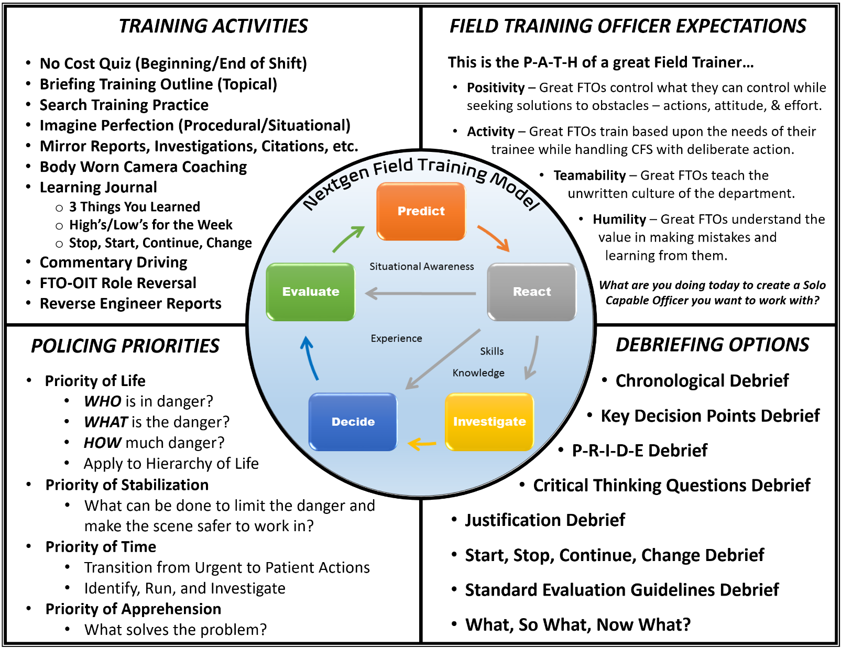
KEY CONCEPTS OF NEXTGEN FIELD TRAINING MODEL TRAINING METHODOLOGY:

- Nextgen Field Training Model’s Training Methodology is based upon multiple concepts compiled into the design of the P-R-I-D-E Adaptive Decision-Making Model and the Policing Priorities.

- The above reference sheet is meant to serve as a guide for Field Training Officers to train and debrief calls for service and self-initiated activities with Officers-In-Training in a way that supports adaptive thinking, experiential learning, and safe law enforcement practices. It addresses each of the following:
  - P-R-I-D-E Adaptive Decision-Making Model
  - Training Activities
  - Critical Thinking Questions
  - Debriefing Options
  - Policing Priorities

- FTOs are responsible for reinforcing this Training Methodology every opportunity they get.

P-R-I-D-E ADAPTIVE DECISION-MAKING MODEL:

- P-R-I-D-E ADAPTIVE DECISION-MAKING MODEL: P-R-I-D-E is an acronym for Predict, React, Investigate, Decide, and Evaluate. It is a decision-making model utilized to help FTOs understand, train, and discuss decision-making with OITs.

- The P-R-I-D-E Adaptive Decision-Making Model is a representation of how the brain processes situational awareness, patient decisions, and urgent decisions.

- Processing information in this manner leads to better, more consistent decision-making.

- Field Training Officers can utilize the P-R-I-D-E Adaptive Decision-Making Model to debrief specific decision(s), calls for service, or self-initiated activities in the chronological order in which decisions are made or the event takes place.

- Example Debriefing Questions:

  - PREDICT
    - Based upon known information, what were you predicting about this situation?
    - What other information would have been helpful to your predictions before arrival?

  - REACT
    - When you arrived, what did you immediately see, hear, think, feel, or notice about the situation?
    - How did the reality of the situation compare to what you had been predicting?

  - INVESTIGATE (Only Occurs During Patient Decision-Making)
    - What information or elements did you believe to be most important to find out in order to make your decision and/or solve the problem?
    - What did you notice about the scene that was important to your investigation?
    - What resources did you utilize or were available to you?
    - What knowledge, skills, and/or previous experiences were relevant to this incident?

  - DECIDE
    - Based upon Predict, React, and Investigate Phases, what decision(s) did you make?
    - Describe the actions, attitude, and effort utilized on this call for service?
      - Action – Specific steps or decisions made.
      - Attitude – Mindset or role utilized.
      - Effort – Level of effort necessary to be successful.
    - What was the legal authority or justification for your actions? (Deliberate Action)
    - Can you justify your decision(s) with the Policing Priorities, law, and/or policy?

  - EVALUATION
    - Was the outcome of this incident what you had originally predicted?
    - What did you do good during this incident?
    - What would you do differently next time?
    - Name one thing you learned that you did not know before this incident.
    - How would you evaluate your performance on this call for service?
STANDARD EVALUATION GUIDELINE CATEGORIES:

- STANDARD EVALUATION GUIDELINES (SEG): The Standard Evaluation Guidelines define the actions, attitude, and effort of a solo capable officer utilizing six categories. These guidelines establish the solo capable officer standard an FTO is trying to assist the OIT in achieving prior to the Evaluation Phases.

- FTOs should utilize the six Standard Evaluation Guideline Categories to focus their training, feedback, debriefs, and evaluations. These categories are where the Critical Tasks and Proficiency Tasks are derived from:
  - CFS/Response Performance
  - Self-Initiated Activity Performance
  - Communication and Relationships
  - Officer Safety Skills/Tactical Safety
  - Law Enforcement Decision-Making
  - Motor Vehicle Operation/Orientation

- See the Standard Evaluation Guidelines on Page 23 for further.

CRITICAL THINKING QUESTIONS:

- CRITICAL THINKING QUESTIONS: A series of questions used to engage an OIT’s mind in thinking through the P-R-I-D-E Adaptive Decision-Making Model.

- The Critical Thinking Questions are a set of five questions that should be utilized before, during, and after a call for service or self-initiated activity to emphasis this method of decision-making.

- IF, WHEN, THEN? (PRE)

  - If, When, Then (Pre) thinking is a prediction-based questioning method utilized to engage the OIT’s imagination in pre-planning a response to a specific set of circumstances.

  - If, When, Then (Pre) thinking should take place enroute to and during a call for service.

    - IF - Sets a predicted action. (Flight, Flight, or Submit)

    - WHEN - Sets a predicted time. (Enroute, Arrive, Contact, or Arrest)

    - THEN - Sets a Pre-Planned Response.

  - Examples of If, When, Then Thinking Questions:

    - IF flight, WHEN enroute, THEN ____________________?

    - IF fight, WHEN arrive, THEN ____________________?

    - IF submit, WHEN contact, THEN ____________________?

- WHAT?

  - What do you know? What do you want to do? What’s important now?

  - What questions should take place enroute to and during a call for service.

- HOW?

  - How do you want to do that? How can we do that?

  - How questions should take place enroute to and during a call for service.

- WHY?

  - Why can we do that? Why is that important? (Legal Authority)

  - Why questions should take place primarily after a call for service.

- IF, WHEN, THEN? (POST)

  - If, When, Then (Post) thinking is a prediction-based questioning method utilized to encourage prediction to slightly altered scenarios to learn more from a single call for service.

  - If, When, Then (Post) should take place after a call for service has been completed by imagining various other alternatives that could have taken place during that call for service.

  - Example: After a consensual contact where a female subject allowed a consent search of her purse. The FTO may ask questions similar to these:

    - What if she had kept walking away from us when you asked to speak to her?

    - What if the subject had refused consent when you asked to search her purse?

    - What if the subject had taken off running when we first made contact then what would you have done?

    - Each of these questions takes a single incident and turns it into a new learning opportunity for the OIT just by slightly altering some of the actual details.

TRAINING DELIBERATE ACTION:

- When conducting police activities, most OIT training focuses on teaching them to try to “control” the involved “other people” and “circumstances.”

- FTO’s should focus OITs on trying to “influence” the “other people” and “circumstances.”

- When OIT’s try to control other people or circumstances, they place themselves in a lose-lose situation. Influencing maintains more adaptability and available option for solving the problem.

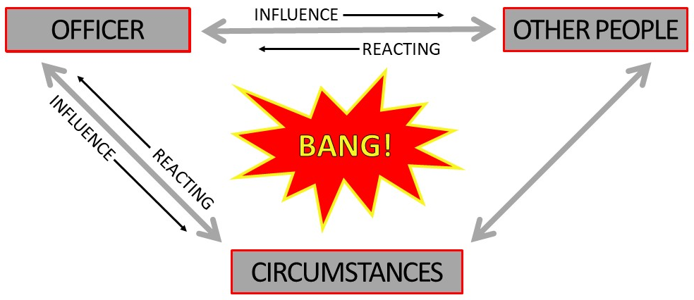

- Teaching OIT’s to “influence” rather than “control” starts by teaching them to control the only things they truly have control over – their actions, attitude, and effort.

- They must be trained to control these three things and utilize them to solve the issue(s) at hand.
  - Action – Specific steps to take or decisions to make.
  - Attitude – Mindset or role to utilize.
  - Effort – Level of effort necessary to be successful.

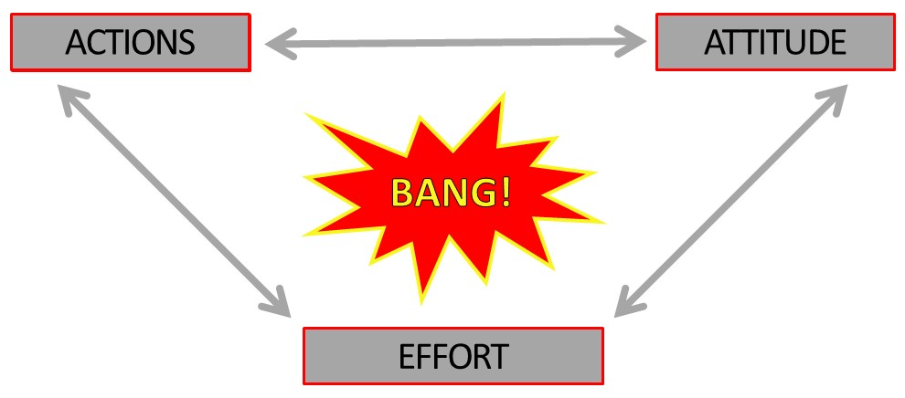

OFFICER SAFETY-BASED PREDICTIVE MINDSET:

- Better predictions are based upon understanding common patterns that take place during nearly all law enforcement encounters.

- Understanding of the relationship between officer safety, the other people involved, and the circumstances of the situation is vital to the development of successful OIT’s.

- Instruction provided to OITs must train them to balance their actions, attitude, and effort in regard to influencing the other people and circumstances of the situation with the following concept:

  - TREAT EVERYONE WITH DIGNITY AND RESPECT, BUT NEVER COMPROMISE OFFICER SAFETY, GOOD TACTICS, OR APPROPRIATE USE OF FORCE.

  - OITs should approach every call for service or self-initiated activity with this in mind.

- During every law enforcement encounter, there are four moments when the stress level of the suspect increases greatly. It is during each of these moments that a suspect is most likely to react negatively to an officer’s actions.

  - Stress Building Moments

    - Police are ENROUTE to the call for service or the suspect becomes aware an officer’s attention has focused on them during self-initiated activity.

    - Police ARRIVE to the call for service or the suspect sees the officer specifically approaching them during self-initiated activity.

    - Police CONTACT is when the one-on-one contact between the suspect and the officer is taking place.

    - Police ARREST occurs when the decision to arrest the suspect becomes imminent, known, or is in the process of occurring to the suspect.

  - All humans have just three options when responding to these high stress moments. These responses can vary greatly in the degree to which they are manifested.

    - FLIGHT – To try to get away from or escape.
      - Literal Example – Foot or Vehicle Pursuits
      - Lesser Manifestation – Look around, turn towards exit, face body away, etc.

    - FIGHT – To stand their ground and resist.
      - Literal Example – Attack with personal weapon, knife, firearm, etc.
      - Lesser Manifestation – Square up, vulgar language attack, clinch fists, etc.

    - SUBMIT – To give into the consequences.
      - Literal Example – Pull over in vehicle, sit on curb, provide ID, etc.
      - Lesser Manifestation – Palms out, releasing breath, slouched posture, etc.
- FLIGHT, FIGHT, MIGHT – This should be the mindset OITs are taught to identify individuals they come into contact with on calls for service or self-initiated activities.

  - Upon arriving at an event, the primary officer safety concern should be if the subject(s) immediately try to FLIGHT or FIGHT.

  - If the subject(s) do not immediately flight or fight, then the secondary officer safety concern becomes that they MIGHT try to flight or fight, if given the opportunity.

  - Train OITs to limit those opportunities through good officer safety, tactics, and appropriate use of force. Train the Critical Tasks.

- Utilizing the common patterns associated with Stress Building Moments and the known Human Reponses to Stress greatly increase an officer’s ability to predict.

- These predictions assist OITs in recognizing potentially dangerous moments during law enforcement encounters and pre-planning potential responses which reduce reaction time.

- FTOs should be reinforcing these common patterns through their training, feedback, coaching, and evaluations to assist OITs in learning to recognize them.

- All of the common patterns associated with Stress Building Moments and the known Human Reponses to Stress are utilized when incorporating If, When, Then (Pre/Post) thinking from the Critical Thinking Questions.

POLICING PRIORITIES:

- POLICING PRIORITIES: The four Policing Priorities are the Priority of Life, the Priority of Stabilization, the Priority of Time, and then the Priority of Apprehension. These priorities should be taught and consistently reinforced by FTOs to train OITs in handling every call for service and debriefing actions taken. The Policing Priorities are an example of a Conceptual Scheme or Framework.

- The Policing Priorities are a hierarchical structure that answer the question “What’s Important Now?” on every call for service or self-initiated activity.

- FTOs should train OITs in utilizing the Policing Priorities to justify decision-making and handling of calls for service.

- The Policing Priorities are applicable to all law enforcement activities.

POLICING PRIORITIES

I. PRIORITY OF LIFE

- RISK ASSESSMENT: Identify WHO is in danger, WHAT is causing the danger, and HOW much danger is present so the appropriate level of risk can be determined.

- Hierarchy of Life – “Risk a lot to save a lot, risk a little to save a little.”
1. Hostages / Victims / Innocents
2. Public Safety Personnel
3. YOU
4. Suspects / Suicidal Subjects
5. Property / Evidence

II. PRIORITY OF STABILIZATION

- The goal of stabilization is to not allow the current circumstances to worsen.

- Make the environment as safe as possible to operate in and continuing to work towards a solution to the situation.

III. PRIORITY OF TIME

- Recognizing when you DO or DO NOT have time to make a decision.

- What determines when you have time? (Priorities 1 & 2)
  - PRIORITY 1 - Is there loss of life, potential loss of life, or serious physical injury?
  - PRIORITY 2 - Is the situation likely to worsen if something is not done quickly?
    - If “YES” to either of the above, Urgent Actions are still necessary.
    - If “NO” to both of the above, it is time to transition to Patient Actions.

- BREATHE . . . then Investigate, Decide, and Evaluate.

- Teach OITs to utilize S.I.R.I. – Stabilize, Identify, Run, Investigate.

IV. PRIORITIY OF APPREHENSION

- Apprehending the suspect and putting together a solid case are absolutely priorities in policing, but they cannot be placed above the Priorities of Life, Stabilization, and Time.

  - Determine appropriate outcome to solve the problem.

  - Questions to Consider: What is the desired outcome?, Are we solving the problem?, What is our intent?, What is appropriate?

STANDARD EVALUATION GUIDELINES

STANDARD EVALUATION GUIDELINE (SEG) CATGORIES:

- CFS/Response Performance
  - CFS-related Activities
  - Cognitive Abilities/General Multi-Tasking
  - CFS-related Compol

- Self-Initiated Activity Performance
  - Self-Initiated Activity
  - Cognitive Abilities/General Multi-Tasking
  - Self-Initiated Compol

- Communication and Relationships
  - Written, Verbal, and Non-Verbal Communications
  - Interpersonal Relationships (Sworn, Non-Sworn, Citizens)
  - Attitude

- Officer Safety Skills/Tactical Safety
  - Officer Safety Skills
  - Officer Safety Multi-Tasking
  - Tactical Safety
  - Emergency Traffic Response

- Law Enforcement Decision-Making
  - Proper Application of Arizona Laws and City Codes
  - Department Policies and Procedures
  - Adaptive/Creative Problem Solving

- Motor Vehicle Operation/Orientation
  - Basic Vehicle Operation and Vehicle Multi-Tasking
  - Code 3/Emergency Response Driving
  - Orientation Skills

* Any significant, repeated issue(s) with any of the Standard Evaluations Categories can be cause for the creation of a Performance Training Plan (PTP), if the issue(s) would prevent the OIT from being a successful solo capable police officer.

CFS/RESPONSE PERFORMANCE:
  - CFS-related Activities
  - Cognitive Abilities/General Multi-Tasking
  - CFS-related Community Policing (Compol)

SOLO CAPABLE OFFICER TASKS:

- Responds to calls for service, investigates, and takes enforcement action (when appropriate) upon suspicious situations or while handling compol activities.

- Appropriately applies Policing Priorities of Life, Stabilization, Time, and then Apprehension.

- Demonstrates the ability to address multiple tasks or issues effectively while applying listed Policing Priorities.

- Thinks through problems by identifying multiple options or alternatives for handling situations.

- Recognizes the need to interview parties and identify who has relevant information.

- Identifies the need to elicit information to clarify circumstances or facts, locate potential evidence, and protect potential evidence.

- Does not hesitate to take action.

- Uses department resources, interacts positively with the community, and incorporates the best interest of the community into his/her problem solving.

- Recognizes compol opportunities and makes appropriate referrals.

- Uses appropriate discretion when deciding to enforce laws, maintain order, utilize social resources, or educate the public.

SELF-INITIATED ACTIVITY PERFORMANCE:
  - Self-Initiated Activity
  - Cognitive Abilities/General Multi-Tasking
  - Self-Initiated Community Policing (Compol)

SOLO CAPABLE OFFICER TASKS:

- Appropriately utilizes uncommitted patrol time to initiate enforcement, take investigative action upon suspicious situations, or initiate compol activities.

- Appropriately applies Policing Priorities of Life, Stabilization, Time, and then Apprehension.

- Demonstrates the ability to address multiple tasks or issues effectively while applying listed Policing Priorities.

- Thinks through problems by identifying multiple options or alternatives for dealing with situations.

- Self-initiates to back up other officers.

- Recognizes the need to interview parties and identify who has relevant information.

- Identifies the need to elicit information to clarify circumstances or facts, locate potential evidence, and protect potential evidence.

- Does not hesitate to take action.

- Uses department resources, interacts positively with the community, and incorporates the best interest of the community into his/her problem solving.

- Uses appropriate discretion when deciding to enforce laws, maintain order, utilize social resources, or educate the public.

- Recognizes compol opportunities and makes appropriate referrals.

COMMUNICATION AND RELATIONSHIPS:
  - Written, Verbal, and Non-Verbal Communications
  - Interpersonal Relationships (Sworn, Non-Sworn, Citizens)
  - Attitude

SOLO CAPABLE OFFICER TASKS:

- Communication skills (written, verbal, and non-verbal) are appropriate, clear, professional, and accurate to the circumstances.

- Ensures all applicable/relevant information is obtained prior to concluding investigative contacts.

- Documents the events and circumstances accurately and without relying solely on the Body Worn Camera (BWC).

- Ensures grammar, spelling, word usage, and sentence structure errors do not compromise clarity of meaning.

- Ensures reports are complete for given set of facts and information.

- Proofreads reports and forms for errors and corrections before submittal.

- Ensures written work meets standards of acceptable submittal quality to the point reports are rarely returned for correction.

- Responds to the radio and computer in an accurate, brief, and clear fashion.

- Listens to transmissions of other patrol units and responds accordingly.

- Uses appropriate codes, etiquette, and provides his/her location when transmitting and receiving information or data.

- Effectively and efficiently uses computers for accomplishing work-related tasks.

- Interactions with sworn, non-sworn, and citizens are based upon dignity and respect to all, without compromising safety, tactics, or utilization of appropriate force.

- Is open to learning and responds positively to feedback while taking responsibility for his/her actions, attitude, and effort.

- Builds and maintains good working relationships with all coworkers and citizens through actions that are not biased in any manner.
OFFICER SAFETY SKILLS / TACTICAL SAFETY:
  - Officer Safety Skills
  - Officer Safety Multi-Tasking
  - Tactical Safety
  - Emergency Traffic Response

SOLO CAPABLE OFFICER TASKS:

- Actions reflect the Policing Priorities of Life, Stabilization, Time, and then Apprehension.

- Utilizes common patterns of law enforcement encounters to make predictions with If, When, Then thinking.

- Does not place self or others at unnecessary risk.

- Reactive to the movements and comments of others and are accompanied by levels of verbal and nonverbal response that control, neutralize, or de-escalate a situation.

- Does not hesitate to provide physical or verbal assistance to other officers when necessary.

- Maintains control of reporting parties, witnesses, and suspects during questioning or interviews.

- Demonstrates officer safety in the listed areas:

  - Does not expose weapons (baton, handgun, TASER, etc.) to suspect(s) or other potential threats.

  - Keeps gun hand free during enforcement situations.

  - Uses tactical positioning when contacting violators and/or vehicles.

  - Influences subject movement and places them in positions of disadvantage, when possible.

  - Maintains sight of the violator while writing citation(s).

  - Searches the police vehicle backseat before duty and after transporting prisoners.

  - Properly searches and/or handcuffs prisoners.

  - Safely and legally conducts pat down searches of suspicious persons when circumstances justify it.

  - Recognizes potential threats and has good situational awareness; utilizes distance, physical barriers, cover, concealment, and other basic officer safety techniques.

LAW ENFORCEMENT DECISION-MAKING:
  - Proper Application of Arizona Laws and City Codes
  - Department Policies and Procedures
  - Adaptive/Creative Problem Solving

SOLO CAPABLE OFFICER TASKS:

- Demonstrates knowledge of and the ability to take appropriate actions based upon the laws of their agency’s jurisdiction.

- Can distinguish between criminal, non-criminal, and civil activity.

- Understands and appropriately applies search, seizure, and arrest laws.

- Utilizes his/her knowledge of and application of traffic laws to make subject contacts and potentially lead to next level investigations.

- Demonstrates the ability to manage vehicle and pedestrian traffic in complex situations, utilizes appropriate safety equipment, and directs other support resources as needed.

- Manages accident investigation scenes and secures pertinent accident reporting information.

- Uses his/her knowledge to apply appropriate department policy and procedure when interacting with others.

- Is familiar with how to access and the department General Orders, Field Orders, and applicable Operations Orders, memorandums, and training guidelines.

- Can apply state law, department policy, and city codes to solve problems.

- Uses appropriate discretion when enforcing laws, maintaining order, utilizing social resources, or educating the public.
MOTOR VEHICLE OPERATION / ORIENTATION:
  - Basic Vehicle Operation and Vehicle Multi-Tasking
  - Code 3/Emergency Response Driving
  - Orientation Skills

SOLO CAPABLE OFFICER TASKS:

- Maintains safe vehicle control while responding to calls for service, self-initiating activity, and during general patrol operations.

- Patrol vehicle speed and operation is reasonable or within emergency response policy guidelines and matches road/traffic conditions.

- Promptly responds to pedestrian and driver action/error by taking evasive action.

- Conducts a pre-use and post-use vehicle inspection and ensures equipment is in good working order.

- Demonstrates knowledge of major streets, intersections, locations, landmarks, hundred block numbering sequence, and patrol area boundaries.

- Determines locations and destinations in a timely manner, with or without the use of maps.

- Is consistently aware of his/her current location.

STANDARD EVALUATION GUIDELINES SCORING RUBRIC:

This is the scoring rubric utilized for Evaluation Phases 4 and 5:

(5) Exceeds Standards:

Trainee was able to accomplish solo capable officer task(s) with no assistance from Field Training Officer and went above and beyond what the typical officer would have done if presented with the same circumstances.

(4) Solo Capable:

Trainee was able to accomplish solo capable officer task(s) with no assistance from Field Training Officer as proficiently as a typical officer presented with the same circumstances. The trainee may use all other resources normally available to a solo patrol officer.

(3) Nearly Solo Capable:

Trainee was able to do most of the solo capable officer task(s), but required some assistance from Field Training Officer to be at an acceptable level. Trainee had some difficulty identifying available options and/or making a decision, but reached an acceptable decision on their own. Assistance could be based upon lack of knowledge, skill, and/or appropriate application.

(2) Not Solo Capable:

Trainee was able to do some of the solo capable officer task(s), but required significant assistance from Field Training Officer to be at an acceptable level. Trainee had significant difficulty identifying available options and/or making a decision, but only reaches an acceptable decision with Field Training Officer assistance. Assistance could be based upon lack of knowledge, skill, and/or appropriate application.

(1) Unacceptable – Not Solo Capable:

Trainee could not complete the solo capable officer task(s) without the Field Training Officer being required to significantly intervene. Intervention may have been necessary due to failure to identify options, failure to make any decision, failure to engage, committed or was about to commit a significant rights violation, and/or committed or was about to commit a significant officer safety violation.

DISCRETIONARY OVERRIDE

- It is the responsibility of the FTO to assume handling responsibilities whenever the OIT is about to significantly violate a CRITICAL TASK:

- OFFICER SAFETY - Place themselves or others in a position of danger, threat, or harm.
- USE OF FORCE - Failing to use the appropriate level of force based upon the circumstances.
- ENGAGEMENT - Failing to engage in lawful police activities and/or conflicts.
- SEARCH/SEIZURE - Violating citizen’s Constitutional Rights.
- MULTI-TASKING - Inability to safely balance multiple simultaneous circumstances.

- Remember to consider whether the OIT is performing incorrectly or merely different from you. FTOs should allow style variations that do not impact the criteria for override.

- It is just as important to know how to execute discretionary override as when.

- When utilizing discretionary override, do so in a manner that maintains the OIT’s dignity. Conduct a thorough debrief of the decision-making that led to the discretionary override and then get them back into training as soon as possible.

PROGRAM STRUCTURE

KEY CONCEPTS OF TRAINING PHASES:

- The primary goal of the Training Phases is for FTOs to work as a TEAM to teach the OIT how to do the job of a solo capable officer.

- The training process consists of three 4-week Training Phases for the OIT to connect the knowledge, skills, and limited experience gained at the police academy with the application of being a solo capable officer. FTOs are cultivating an OIT’s applied knowledge and skills into experience.

- Phases 1, 2, and 3 are set up in the crawl, walk, run experiential learning format.

  - As exposure to Proficiency Tasks increases, the role of the OIT transitions in this manner...

    - Learning -> Trying -> Doing.

  - As exposure to Proficiency Tasks increases, the role of the FTO transitions in this manner...

    - Trainer -> Coach -> Mentor.

  - As the OIT transitions through the Training Phases, the reliance upon the FTO should lessen and the OIT will be expected to utilize other available resources to answer questions in preparation for the Evaluation Phases. (Progressive Independence)

- Daily Observation Reports (DOR) are completed by the FTO to document both the performance of the OIT and any applicable training provided. See Daily Observation Report on Page 59 for further.

- DOR documentation should not only focus on areas of improvement for the OIT, but also on things they are doing correctly.

- There is no scoring on Daily Observation Reports during the Training Phases.

- Train, reinforce, and debrief decision-making utilizing the P-R-I-D-E Adaptive Decision-Making Model and Policing Priorities. Focus on training deliberate action – train OITs to know what they are doing and why they are doing it.

- Proficiency Tasks (formerly known as Critical Tasks) are no longer assigned to specific Training Phases.

  - Not having Proficiency Tasks assigned to specific phases creates a better learning environment to make the information they are learning stick. This utilizes desirable difficulties, effortful retrieval, interleaving, and spacing.

    - Desirable Difficulties - Manufactured difficulties in the learning process that cause the OIT to expend more effort recalling relevant information to handle the situation.

    - Effortful Retrieval - Struggling to generate an answer/solution on your own, even a wrong one, enhances learning. This occurs when an OIT has to struggle to recall information they have been taught/learned previously.

    - Interleaving - The mixing up of multiple training topics/concepts over time to instigate effortful retrieval.

    - Spacing - Providing time between tasks to create the desirable difficulty in recalling the information. (Example - Recalling how to handle a certain type of investigation after not having done one for a while.)

    - It is vital to understand that this will feel more frustrating in the short term for both FTOs and OITs, but will be better for the OIT’s learning retention in the long term.

  - Movement between phases is not slowed by lack of exposure to Proficiency Tasks. OIT performance will be documented and continued to be worked on as the OIT progresses.

- Only Critical Task or significant SEG issues that would prevent an OIT from being a successful solo capable officer will prevent an OIT from moving to the next phase of training.

  - Critical Tasks - Tasks that could potentially get the OIT or someone else hurt/killed or put the department in significant liability
    - Officer Safety
    - Use of Force
    - Engagement
    - Search and Seizure
    - Multi-tasking

  - All of the Critical Tasks are specifically addressed in the Standard Evaluation Guidelines. See more in the Standard Evaluation Guidelines section on Page 23.

  - If an OIT is having significant difficulty grasping any of the Critical Tasks, a 2-week Performance Training Plan may be developed by the FTO and Field Training Staff to address the specific issue(s). See more in the Performance Training Plan section on Page 75.

  - When an FTO begins to notice a pattern developing of an OIT having issues with a Critical Task(s), they will designate those DOR notes with an asterisk (*) at the end. This will make those examples and the training provided easily searchable for the development of a Performance Training Plan.
PHASE 1 – TRAINING (Crawl) – 4 WEEKS:

- Primary goal is for the OIT to LEARN and the FTO to TRAIN how to do the job of a solo capable officer.

- Phase 1 training is focused on the OIT learning foundational operating procedures of being a solo capable officer - using radio/MDC, locating addresses, utilizing resources, initiating traffic stops, initiating subject contacts, getting exposure to a wide variety of calls for service, and learning to apply the Critical Tasks properly.

  - 10 Traffic Stops and 10 Field Interview Cards are required in Phase 1.

    - These are the only Proficiency Tasks required in a specific Training Phase.

    - These tasks interleave multiple foundational aspects of policing.

    - Doing these tasks multiple times within a short timeframe provides the OIT an opportunity for some “quick wins” to generate confidence.

  - The Phase 1 FTO is a “foundational” trainer. Assist the OIT in creating a solid law enforcement foundation to build the rest of their field training upon.

  - The Phase 1 FTO’s mission is to train in and expose the OIT to as many of the Proficiency Tasks as possible as the OIT begins grasping the foundational operating procedures.

  - Repeated exposure, especially to infrequent CFS, is encouraged and beneficial to the OIT’s learning. Take experiential learning opportunities as they present themselves.

- Experiential Learning – FTOs assist the OIT in building connections between their experiences applying the Critical Tasks and handling Proficiency Tasks with the knowledge/skills gained from the police academy. More Experiences = More Learning.

- No scoring on Daily Observation Reports (DOR).

- Administrative Tasks
  - Review Phase 1 Expectations
  - Exposure Forms – Daily
  - Proficiency Tasks – Daily
  - Daily Observation Reports – Daily
  - Mid-Phase Self-Evaluation Form
  - Phase Board Form – Phase 1 to Phase 2
  - Review Phase 2 Expectations at Phase Board

PHASE 2 – TRAINING (Walk) – 4 WEEKS:

- Primary goal is for the OIT to TRY and the FTO to COACH how to do the job of a solo capable officer.

- Phase 2 training is focused on the OIT trying to demonstrate proper operating procedures of being a solo capable officer, utilizing resources, getting exposure to a wide variety of calls for service and self-initiated activities, and applying the Critical Tasks properly.

  - The Phase 2 FTO is an “exposure” trainer. Utilize the Exposure Forms and Proficiency Tasks to determine the types of calls for service and/or self-initiated activities the OIT needs exposure to.

  - The Phase 2 FTO’s mission is to train in and expose the OIT to as many of the Proficiency Tasks as possible.

  - Repeated exposure, especially to infrequent CFS, is encouraged and beneficial to the OIT’s learning. Take experiential learning opportunities as they present themselves.

- No scoring on Daily Observation Reports (DOR).

- Administrative Tasks
  - Exposure Forms – Daily
  - Proficiency Tasks – Daily
  - Daily Observation Reports – Daily
  - Mid-Phase Self-Evaluation Form
  - Phase Board Form – Phase 2 to Phase 3
  - Review Phase 3 Expectations at Phase Board

PHASE 3 – TRAINING (Run) – 4 WEEKS:

- Primary goal is for the OIT to DO and the FTO to MENTOR how to do the job of a solo capable officer.

- Phase 3 training is focused on the OIT trying to demonstrate proper operating procedures of being a solo capable officer, utilizing resources, getting exposure to a wide variety of calls for service and self-initiated activities, and applying the Critical Tasks properly.

  - The Phase 3 FTO is a “cleanup” trainer. Utilize the Exposure Forms and Proficiency Tasks to determine the types of calls for service and/or self-initiated activities the OIT needs exposure to before moving into the Evaluation Phases

  - The Phase 3 FTO’s mission is to get the OIT exposure to CFS and/or self-initiated activities that Phase 1 and 2 were unable to get and provide additional repeated exposures to tasks they have previously done.

  - Repeated exposure, especially to infrequent CFS, is encouraged and beneficial to the OIT’s learning. Take experiential learning opportunities as they present themselves.

- Phase 3 is still a Training Phase and should NOT be treated as a “practice” Evaluation Phase. Allow OIT to do as much as they can with Proficiency Tasks they have previous experience with, but provide training to Proficiency Tasks they have not experienced previously. FTO should assist them in identifying commonalities between the new task(s) and their previous experiences.

- All Proficiency Tasks must be signed off before the OIT can move to Phase 4.

- An Extension Plan may be developed at the end of Phase 3 to add additional time to finish getting exposure to Proficiency Tasks before the OIT moves to Phase 4 Evaluation Phase.

- Phase 3 may be eliminated for lateral or waiver officers to accelerate their field training, but they will still be expected to show proficiency at all Proficiency Tasks during the Evaluation Phases.

- No scoring on Daily Observation Reports (DOR).

- Administrative Tasks
  - Exposure Forms – Daily
  - Proficiency Tasks – Daily
  - Daily Observation Reports – Daily
  - Mid-Phase Self-Evaluation Form
  - Phase Board Form – Phase 3 to Phase 4
  - Review Phase 4 Expectations at Phase Board

KEY CONCEPTS OF EVALUATION PHASES:

- Primary goal is to EVALUATE the OIT’s ability to perform at a solo capable officer level.

- The evaluation process consists of three Evaluation Phases to observe the application of knowledge, skills, and limited experience learned at the police academy combined with the experience gathered through Training Phases 1, 2, and 3.

- To be moved into the Evaluation Phases, an OIT must consistently demonstrate the ability to properly apply the Critical Tasks and has been trained in, exposed to, and/or has a working understanding of all Proficiency Tasks.

- Throughout the Evaluation Phases, the OIT is acting as a solo capable officer with the FTO there primarily serving as an evaluator. FTO still has the authority to invoke Discretionary Override, if necessary.

  - FTO should still provide training on infrequent tasks the OIT comes across during these phases.

    - If training is provided by the FTO to the OIT during the call for service to get them through it successfully, the DOR scoring will reflect this appropriately.

    - If training is provided by the FTO to the OIT after the call for service to train the OIT and improve their performance the next time they experience this type of call, there will be no negative affect to the DOR scoring.

    - If the OIT utilizes other available resources to answer their questions and get through the call for service successfully, there will be no negative affect to the DOR scoring.

  - A single infrequent task the OIT struggles with will not prevent them from passing an Evaluation Phase.

- Daily Observation Report (DOR) scoring will be completed for every call for service utilizing the solo capable officer standard in the Standard Evaluation Guidelines.

  - Scoring DORs only in the Evaluation Phases will remove scoring inconsistencies because the FTOs will only be scoring officers that have received ALL pre-requisite training and should be solo capable.

  - DOR Standard Evaluation Guidelines Scoring Rubric:

    - 5 = Exceeds Standard of a Solo Capable Officer
    - 4 = Solo Capable
    - 3 = Nearly Solo Capable
    - 2 = Not Solo Capable
    - 1 = Unacceptable: Not Solo Capable

- After each call for service, OIT debriefs and supports their decision-making utilizing the P-R-I-D-E Adaptive Decision-Making Model and Policing Priorities. The OIT will demonstrate deliberate action – they know what they are doing and why they are doing it.

- At the end of Phases 4 and 5, if the OIT is unable to demonstrate proper usage of the Critical Tasks and/or is having significant difficulty performing Proficiency Tasks they have been signed off on, the FTO can initiate a Performance Training Plan to work on the identified issue(s).

  - A Performance Training Plan may only be initiated if the FTO’s DOR documentation supports their observations.

  - If a Performance Training Plan is initiated, that Evaluation Phase will not count and the OIT will still need to pass 2 Evaluation Phases before moving on to the Solo Phase.

  - OITs will only be given one Performance Training Plan after they reach the Evaluation Phase.

  - If they are not successful in the Evaluation Phase after completing a Performance Training Plan, the OIT will be referred to the Field Training Review Committee.

- Interpretation of Evaluation Phase Results

  - Two FTO Evaluators pass OIT. -> OIT moves to Solo Phase on assigned patrol squad.

  - FTO Evaluators differ on passing OIT. -> OIT receives a Performance Training Plan to address that Evaluator’s specific concerns and then must pass a third Evaluation Phase.

  - Two FTO Evaluators fail OIT. -> OIT is referred to the Field Training Review Committee.
PHASE 4 – EVALUATION (Crawl) – 2 WEEKS:

- Phase 4 Evaluator, when available, will be the same FTO the OIT had for Phase 1. If the Phase 1 FTO is unavailable, then the Phase 2 FTO will be the next choice for Phase 4.

  - This provides a bridge between the Training and Evaluation Phases for the OIT

  - The OIT will start the evaluation process with a familiar FTO, squad, and district.

- Primary goal is to EVALUATE the OIT’s ability to perform at a solo capable officer level.

- FTO should be aware of the OIT’s call management abilities and be sure they are not avoiding engagement or involvement in calls for service or situations they should be proactive about handling.

- FTO should still track OIT activities on the Exposure Forms.

- Administrative Tasks
  - Exposure Forms – Daily
  - Daily Observation Reports – Daily
  - Phase Board Form – Phase 4 to Phase 5
  - Review Phase 5 Expectations at Phase Board

PHASE 5 – EVALUATION (Walk) – 2 WEEKS:

- Phase 5 Evaluator will be an independent FTO that has not worked directly with the OIT.

  - This is to build the OIT’s self-reliance to assist in their success when they are solo.

  - The independent evaluator also limits potential biases in the OIT’s success or failure.

- Primary goal is to independently EVALUATE the OIT’s ability to perform at a solo capable level.

- Because this Evaluation Phase uses an independent evaluator, the OIT may or may not have previously worked in this district, with this squad, or met the FTO. While the FTO will be providing an independent evaluation of the OIT’s ability to operate as a solo capable officer, this should NOT keep the FTO from welcoming the OIT to the squad, introducing them to the district, and/or showing them where resources are located.

- FTO should be aware of the OIT’s call management abilities and be sure they are not avoiding engagement or involvement in calls for service or situations they should be proactive about handling.

- FTO should still track OIT exposure on the Exposure Forms.

- When scheduling the Phase 5 to Solo Phase Board, the FTO should include the FTO Program Manager in the process. At least one member of the FTO Staff will attend this Phase Board to verify the OIT and sergeant understand their roles and responsibilities for the upcoming Solo Phase.

- Administrative Tasks
  - Exposure Forms – Daily
  - Daily Observation Reports – Daily
  - Phase Board Form – Phase 5 to Solo Phase
  - Receiving Sergeant Advises of their Squad Expectations at Phase Board

SOLO PHASE – EVALUATION (Run) – 4 WEEKS:

- In the Solo Phase, the OIT will be monitored by their new assigned squad sergeant.

- Primary goal is to EVALUATE the OIT’s ability to perform at a solo capable officer level while operating on their assigned patrol squad under the supervision of their assigned sergeant.

- To get to the Solo Phase, the OIT must have been passed by two Field Training Evaluators.

- If the sergeant will be off during the time of an OIT’s Solo Phase, they should utilize the following options to make their decision on releasing the OIT from the Field Training Program:
  - Ask an overlapping supervisor to provide feedback on the OIT’s performance.
  - Ask the squad officer-in-charge to provide feedback on the OIT’s performance.
  - Review body worn camera footage of the OIT handling calls for service.
  - Ask the Field Training Staff for an extension to make your own observations.

- If the OIT is successful in the Solo Phase, they will be fully released from the Field Training Program by their assigned sergeant and will be considered a solo capable officer. While considered a solo capable officer in regard to the Field Training Program, they are still under the probationary status as a new city employee.

- If the supervisor has significant concerns about the OIT’s ability to perform at a solo capable level, a Performance Training Plan will be initiated, if they have their Evaluation Phase PTP still available.

  - An FTO will be brought to the OIT’s Squad to train them in the environment and conditions they will be operating in as a solo capable officer.

  - The Squad Sergeant will provide Field Training Staff with the specific Critical or Proficiency Tasks the OIT needs to improve on and examples of deficiencies.

  - The Field Training Staff will develop the Performance Training Plan.

- The OIT must pass another Solo Phase Evaluation after completing the Performance Training Plan.

- Post-Field Training Issues: The continued develop of a new officer is the responsibility of their assigned sergeant and chain of command. If performance issues arise post-FTO while still on probation, they should be handled by utilizing Monthly Probation Evaluations, Coaching/Mentoring Sessions, and, if necessary, a Performance Improvement Plan (PIP) through PD-Human Resources.

- Administrative Tasks
  - Complete the Release from Field Training Form.
  - Meet with the OIT to review strengths and any area(s) for improvement.
  - Both the sergeant and officer sign the Release from Field Training Form.
  - Send the entire Field Training Workbook to the Field Training Staff or advise that it is ready to be picked up.

FIELD TRAINING WORKBOOK

KEY CONCEPTS OF THE FIELD TRAINING WORKBOOK:

- The Field Training Workbook, when complete, will create the Field Training File for an OIT. Keeping this book up to date through an OIT’s training is vital to their success in the Field Training Program.

- Along with Daily Observation Reports, the Field Training Workbook serves as a primary communication source for tracking an OIT’s progress through their Training and Evaluation Phases.

- The Field Training Workbook contains all necessary forms for an OIT to complete field training.
  - Exposure Forms
  - Proficiency Tasks Phase Expectation Forms
  - Mid-Phase Self-Evaluation Forms
  - Phase Board Forms
  - Release from Field Training Form

- The FTO should update the Exposure Forms and Proficiency Tasks at the end of each shift. This will assist with the writing of Daily Observation Reports and connecting the activities done by the OIT to the training provided during each shift.

- If an OIT has a Performance Training Plan, the FTO will be responsible for printing additional Self-Evaluation Pages to add to the Field Training Workbook in the appropriate section of the workbook. A signed copy of the Performance Training Plan will also be included.

EXPOSURE FORMS:

- PROFICIENCY TASK(S): Proficiency Tasks are foundational knowledge, skills, and experiences an OIT must receive training in and exposure to prior to being moved from Training to Evaluation Phases.

- EXPOSURE FORMS: This form is used to track the number of exposures an OIT has to specific Proficiency Task activities.

- It serves as a quick reference for FTOs and supervisors to view the number of times an OIT has performed a specific task and how much of that task the OIT did.

  - The major benefit of the Exposure Forms is the ability to quickly and easily demonstrate the usage of the crawl, walk, run philosophy and where an OIT stands with each task.

  - The Exposure Forms should be updated at the end of each field training shift.

  - For each task an OIT is exposed to, the FTO will fill in the box with a “C” for Crawl, a “W” for Walk, or “R” for Run with the Phase Number next to it.

    - Crawl = 0 – 25%, Walk = 25 – 75%, and Run = 75 – 100%

    - “C1” means the OIT completed 0 – 25% of the task on their own in Phase 1.
    - “W2” means the OIT completed 25 – 75% of the task on their own in Phase 2.
    - “R3” means the OIT completed 75 – 100% of the task on their own in Phase 3.

- Example of Exposure Forms (Front):

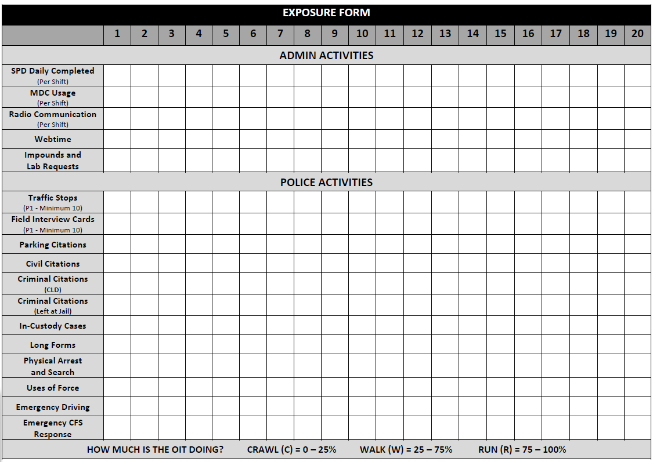
- Example of Exposure Forms (Back):

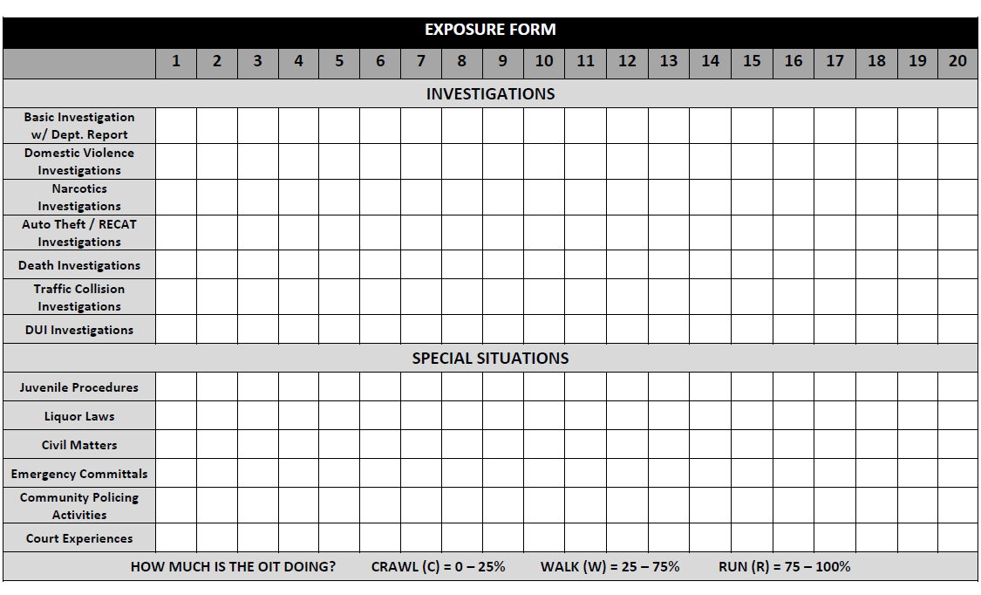

PROFICIENCY TASKS:

PROFICIENCY TASKS: These training topics list the knowledge, skills, and experiences an OIT must be exposed to throughout the three Training Phases.

- Proficiency Task Sections include all of the following:
  - CFS/Response Activity
  - Self-Initiated Activity
  - Traffic Stops
  - Contacting Subjects
  - Field Interview Cards
  - MDC Usage
  - Radio Communication
  - Payroll Tracking
  - Impounds and Lab Requests
  - Parking Citations
  - Criminal Citations
  - Prosecution Procedures (In-Custodies/Long Forms)
  - Use of Force
  - Arrests
  - Searches and Seizure
  - Basic Investigations
  - Domestic Violence Investigations
  - Narcotics Investigations
  - Auto Theft/RECAT Investigations
  - Death Investigations
  - Traffic Collision Investigations
  - DUI Investigations
  - Traffic Scene Management
  - Emergency Driving
  - Emergency CFS Response
  - Juvenile Procedures
  - Liquor Laws
  - City Codes
  - Civil Matters
  - Emergency Committal Orders
  - Community Policing
  - Court Experiences
  - Body Worn Cameras – Patrol Usage

- Each Proficiency Task Section is broken down into specific Proficiency Tasks that define the exact items the OIT must receive training in and/or exposure to during their Training Phases.

- Proficiency Tasks are not assigned to specific phases of training and will be taught as calls for service, self-initiated activity, and time allow.

  - Already having exposure to a Proficiency Task Training Topic should not prevent the OIT from receiving repeated training in or exposure to a specific topic.

  - This creates the desirable difficulties of spacing and effortful retrieval in the OIT’s learning by forcing them to recall previous used/learned information.

- Training Phase FTOs must be well aware of the training needed by the OIT and be diligent about getting them those calls for service or self-initiated activities as opportunities present.

- Completing the Proficiency Task pages:

  - FTOs should check the corresponding phase box next to any Proficiency Task Training Topic they provided training in and/or exposure to during a shift. Only check the box if the FTO feels the topic has been adequately covered.

  - After each Proficiency Task Section has had all of the individual training topics instructed, both the OIT and FTO should initial and date that it has been completed and is understood.

  - If a Proficiency Task Training Topic is covered by FTOs in more that one phase, each applicable phase box should be checked to show that the OIT has received training on the topic during multiple phases. This is done by utilizing the 1, 2, 3 boxes.

  - This should be done after each call for service or at the end of each training shift.

- Example of Proficiency Task pages:
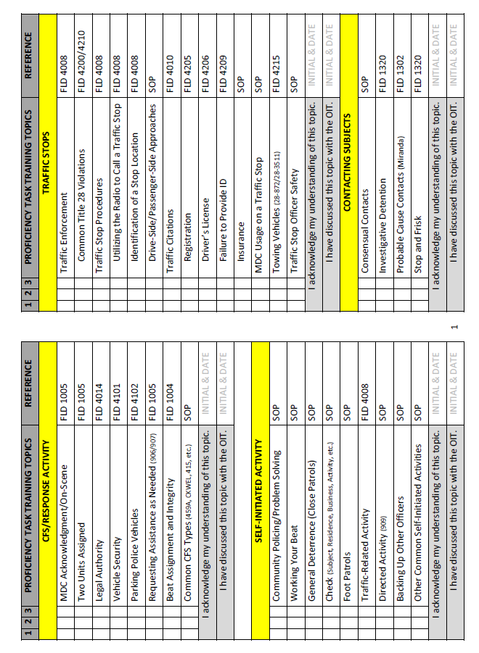
MID-PHASE SELF-EVALUATION FORM:

- MID-PHASE SELF-EVALUATION FORM: A Mid-Phase Self-Evaluation form is completed halfway through the phase by the OIT and shared with their FTO. This form is utilized to ensure that the OIT and FTO are on the same page regarding the OIT’s training progress.

- Mid-Phase Self-Evaluation Forms are utilized as a reflection device by asking the OIT to think back to what they did throughout their work week and address the following:
  - Performance areas they excelled in.
  - Performance areas most challenging for them.
  - Officer safety or search/seizure issues (Critical Tasks) they were made aware of.
  - Any additional training that could be provided to them by the FTO and/or FTO Program.

- The Phase Board Form serves as the Self-Evaluation during the last week of a phase.

- Asking the OIT to remember what they previously experienced and the feedback provided by the FTO is an example of effortful retrieval and assists in the OIT’s retention of learned information.

- Example of a Self-Evaluation Form:
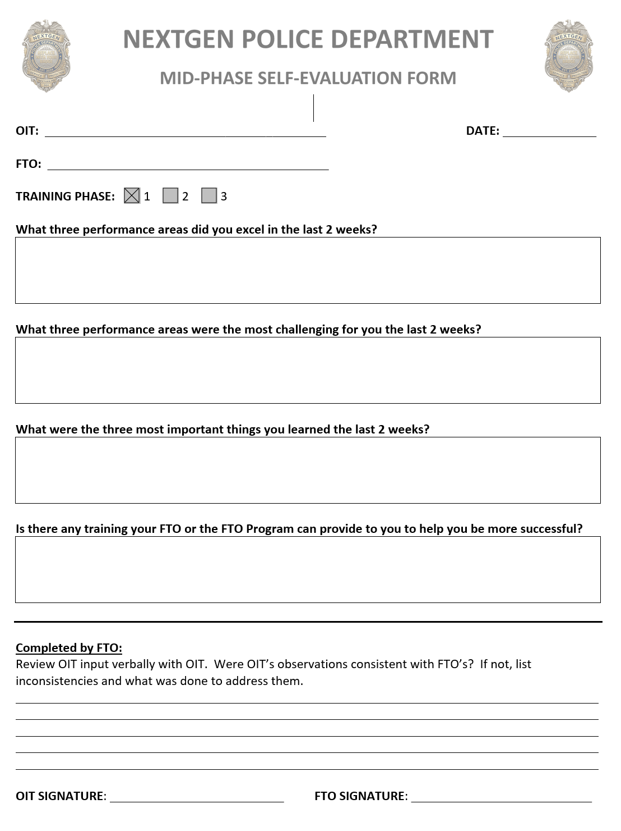

PHASE EXPECTATIONS:

- PHASE EXPECTATIONS: Specific expectations for success assigned to each phase of the Field Training Program. These are covered at the beginning of each phase of training and at Phase Boards when transitioning the OIT to their next phase of training.

- Phase Expectations address the following topics:
  - An overview of the specific phase they are starting.
  - A description of the workload for the upcoming phase.
  - An explanation regarding how the OIT will either debrief activities or be evaluated based upon if they are in a Training or Evaluation Phase.
  - An explanation of the OIT’s priorities while in the Field Training Program.

- There are Phase Expectations for Phases 1, 2, 3, 4, and 5 and they are pre-printed for each Field Training Workbook so they can be utilized during Phase Boards.

- When an OIT reaches the Solo Phase of their evaluation process, the assigned sergeant should provide the OIT their own squad expectations.

- Example of a Phase Expectation Form:
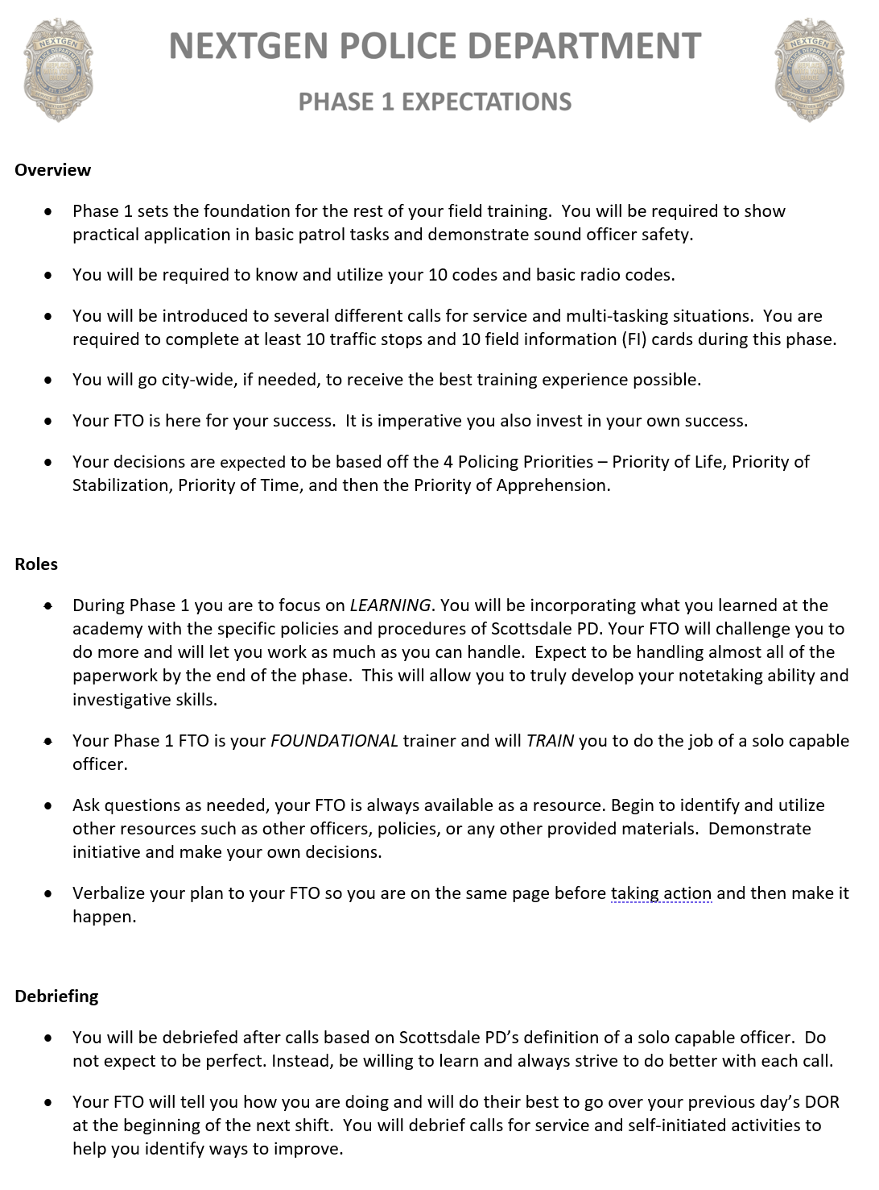

PHASE BOARD FORM:

- PHASE BOARD FORM: This form is utilized to conduct a Phase Board meeting and ensure that all necessary topics are covered before an OIT transitions from one phase to the next.

- The following individuals should be included in a Phase Board:

  - Officer-In-Training (Mandatory)

  - Outgoing Field Training Officer (Mandatory)

  - Outgoing Sergeant (Preferred)

  - Incoming Field Training Officer (Mandatory)

  - Incoming Sergeant (Mandatory)

  - Patrol Lieutenant (Optional)

  - Field Training Staff (Optional or Upon Request) - A member of the Field Training Staff will be present at all of Phase 5 to Solo Evaluation Phase Boards.

- Conducting a Phase Board:

  - The Outgoing FTO is responsible for providing the Phase Board Form from the Field Training Workbook.

  - Prior to the Phase Board beginning, the Outgoing FTO completes the Field Training Officer Comments on Page 1 of the Phase Board Form.

  - FTO provides OIT Page 2 of the Phase Board Form to complete the Officer-In-Training Self-Assessment section in a separate space from where the Phase Board is being held.

  - Sergeants and FTOs then discuss Page 1 of the Phase Board Form without the OIT present.
    - Outgoing FTO and Outgoing Sergeant (if present) provide a status debrief regarding the OIT’s training progress.
    - Outgoing FTO reviews training covered from the Exposure Forms.
    - Outgoing FTO reviews the Proficiency Tasks that have been covered during their Training Phase and what topics OIT still needs exposure to.
    - Outgoing FTO discusses the status of their Daily Observation Reports.
    - Outgoing FTO discusses the status of the OIT’s iLeads workload.
    - Outgoing FTO and Outgoing Sergeant (if present) discuss the OIT’s Critical Task performance and any related issues, if applicable.
    - Outgoing FTO provides a recommendation for the OIT to move on to the next phase of their training.
    - Outgoing FTO and Outgoing Sergeant (if present) discuss OIT’s strengths and areas for improvement.

  - Outgoing FTO retrieves OIT to join the Phase Board and makes introductions.
    - Outgoing FTO provides a summary of what has already been discussed to the OIT.
    - OIT reviews what they wrote regarding their strengths, area(s) of improvement, and requests for any additional training.
    - Incoming FTO reviews the OIT’s new schedule and chain of command.
    - Incoming FTO and Outgoing FTO discuss a plan for handling any outstanding administrative issues. (ie. outstanding DORs or paper, schedule issues, etc.)
    - Incoming FTO and Incoming Sergeant review Phase Expectations to include workload, learning environment, and feedback model.

  - All parties present at Phase Board sign the Phase Board Form.

  - Outgoing FTO returns the completed Phase Board Form to the Field Training Workbook.

- Example of a Phase Board Form:

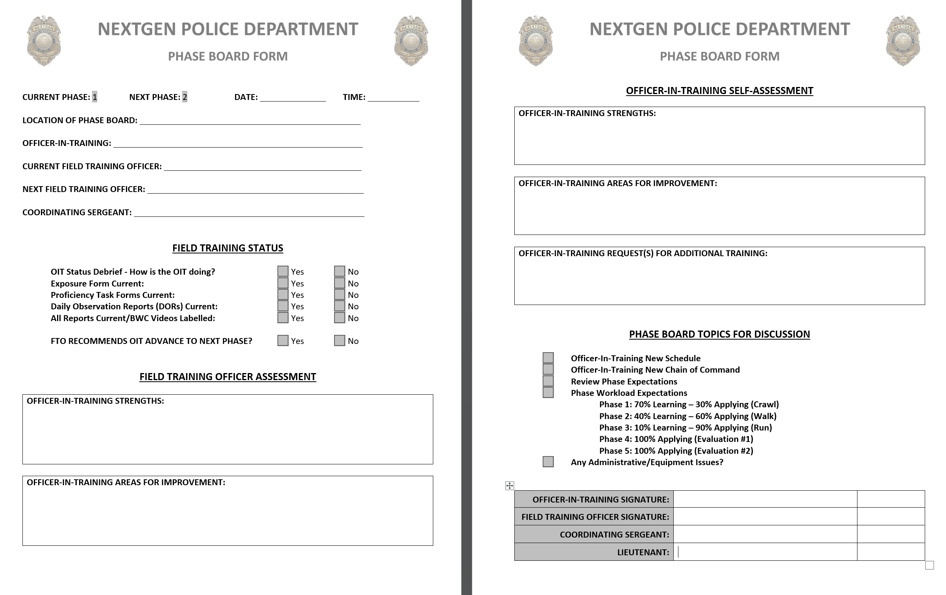
RELEASE FROM FIELD TRAINING FORM:

- RELEASE FROM FIELD TRAINING FORM: This form is completed by the OIT’s newly assigned sergeant after four weeks of monitoring. If the sergeant feels the OIT has successfully reached the level of a new solo capable officer, then they complete this form to release the OIT from the Field Training Program.

- It is incumbent of the sergeant to get out and observe the OIT handle calls for service and self-initiated activities during this observation period to assist in completing the Release from Field Training Form.

- The assigned sergeant does not complete Daily Observation Reports during the four-week monitoring period, but should keep any performance notes they normally would.

- Conducting a Release from Field Training Meeting:

  - Sergeant retrieved Release from Field Training Form from the OIT’s Field Training Workbook.

  - Sergeant answers the Officer Status questions.

  - If sergeant selects “No” for any of the Officer Status questions, they must contact the Field Training Program Manager immediately to discuss training options.

  - Sergeant completes the Sergeant Comments section by commenting on the OIT’s strengths and areas for improvement.

  - Sergeant arranges a one-on-one meeting time with the OIT to discuss the sergeant’s comments on the form and the OIT’s release from Field Training.

  - Sergeant and OIT sign the Release from Field Training Form.

  - Sergeant returns the Release from Field Training Form to the Field Training Workbook.

  - Sergeant returns Field Training Workbook to the Field Training Staff or advises that it is ready to be picked up.

- Once the Release from Field Training Form is completed, the OIT is now considered a solo capable officer and is released from the Field Training Program. (Note: While considered a solo capable officer in regard to the Field Training Program, they are still under the probationary status of a new city employee.)

- Post-Field Training Issues: The continued develop of a new officer is the responsibility of their assigned sergeant and chain of command. If performance issues arise post-FTO while still on probation, they should be handled by utilizing Monthly Probation Evaluations, Coaching/Mentoring Sessions, and, if necessary, a Performance Improvement Plan (PIP) through the department’s Human Resources.

- Example of a Release from Field Training Form:

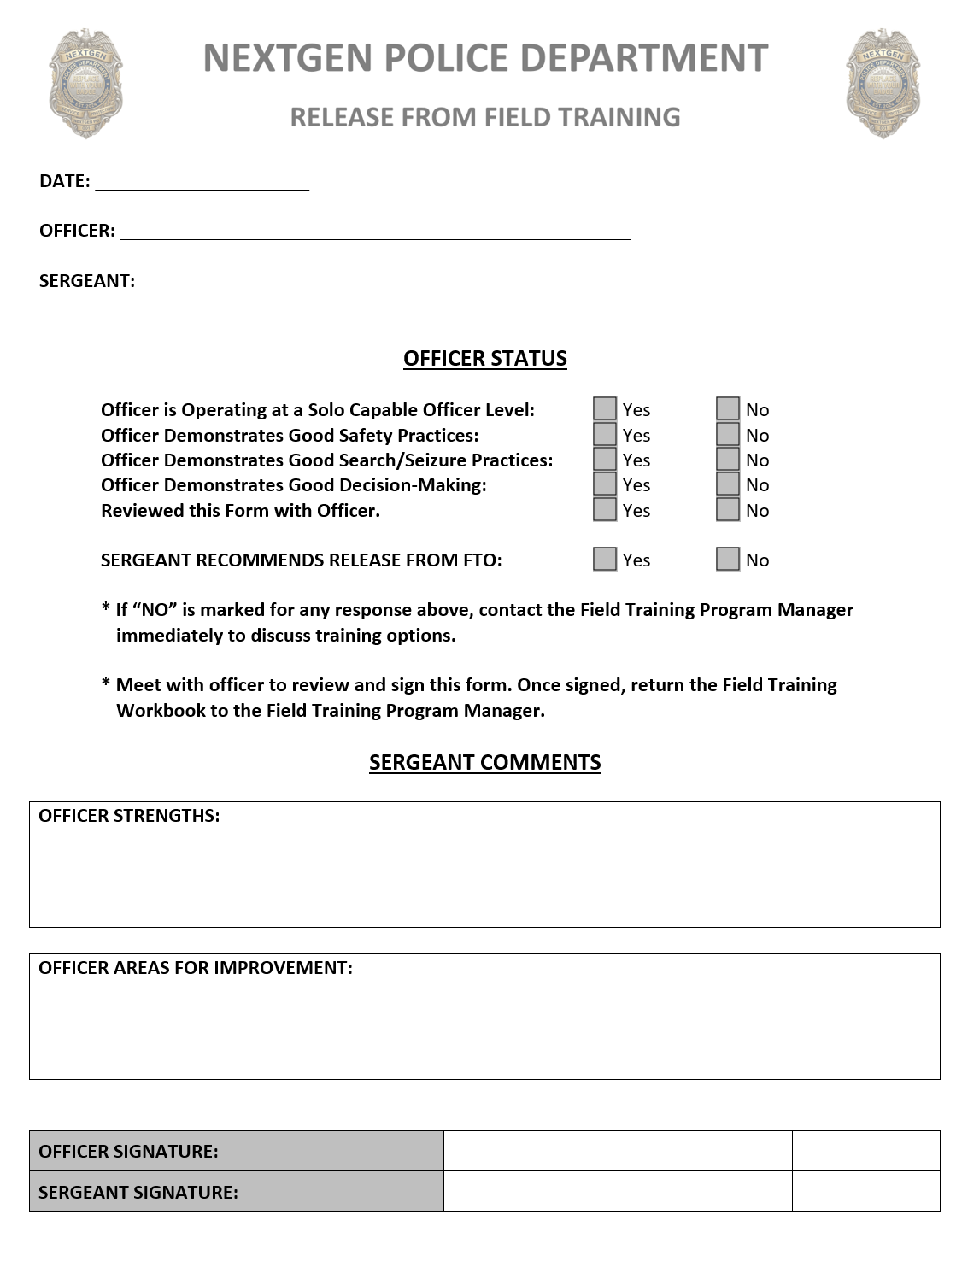

DAILY OBSERVATION REPORTS

KEY CONCEPTS OF DAILY OBSERVATION REPORTS (DORs):

- DAILY OBSERVATION REPORT (DOR): Daily Observation Reports are completed by the FTO to document both the performance of the OIT and the applicable training provided.

- A DOR is completed for each shift the OIT works and includes documentation observations related to each call for service or self-initiated activity the OIT handles. DORs completed during Training Phases do not get scored. DORs completed during the Evaluation Phases do get scored using the Standard Evaluation Guidelines.

- Documentation of the Critical Tasks and the Proficiency Tasks should reflect comprehension of the training provided and not the amount of time spent providing that training.

- Document the OIT’s actions (what/how/why) and any training provided in each applicable Standard Evaluation Guideline (SEG) Category. It is vital to have the proper documentation in the proper SEG Category – See SEG Section on Page 23 for further.

- For each call for service or self-initiated activity handled by the OIT, the following SEG Categories should be utilized:
  - Call for Service/Response Performance OR Self-Initiated Activity Performance
  - Communication and Relationships (Applicable to every activity.)
  - Officer Safety Skills/Tactical Safety (Applicable to every activity.)
  - Law Enforcement Decision-Making (Applicable to every activity.)
  - Motor Vehicle Operation/Orientation (When applicable to the activity.)

- Documentation should be specific to each SEG category and a reflection of the actions taken by the OIT along with the FTO’s feedback and training provided.

- Documentation can be about good things the OIT did, as well as, areas for improvement. 80% of the reason for doing DORs is to reinforce desired actions, training given, and ways to improve for the OIT. Only about 20% of the DOR is for the purpose of department liability and/or potentially removing an OIT from the program.

- Documentation should be based upon a comparison of the actions taken by the OIT and the solo capable officer descriptions in the Standard Evaluation Guidelines.

- A Performance Training Plan may only be initiated if the FTO’s DOR documentation supports the necessity for one.
- Daily Observation Report Writing Process:
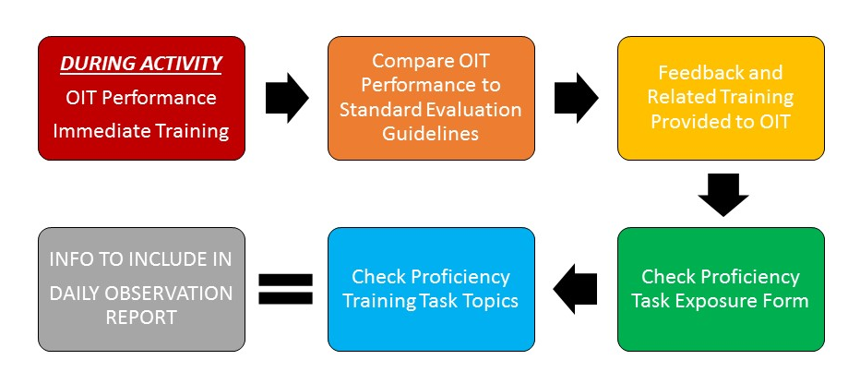

TRAINING PHASE DAILY OBSERVATION REPORTS

- Daily Observation Reports (DORs) are completed by the FTO to document both the performance of the OIT and the applicable Critical Task or Proficiency Task training provided.

- There is no scoring on DORs during Training Phases.

- The Exposure Forms should be completed by the end of each shift.

  - The use of this form will provide guidance in drafting the narrative for the DORs.

  - It also assists in connecting the activities done by the OIT to the training provided.

- The Proficiency Tasks are used as a guide for the activities the OIT should be exposed to during each shift.

  - The Training Topics are not phase specific and should be covered in a craw, walk, run format.

  - As many Training Topics as possible should be covered in each phase, even if OIT has previous exposure to the task.

  - FTOs should work as a team to ensure that all Proficiency Tasks will be covered throughout the OIT’s Training Phases.

  - Communicate with the other FTOs regarding the topics most likely to be exposed to on your shift in your district.

- Example of a Training Phase Daily Observation Report Entry:

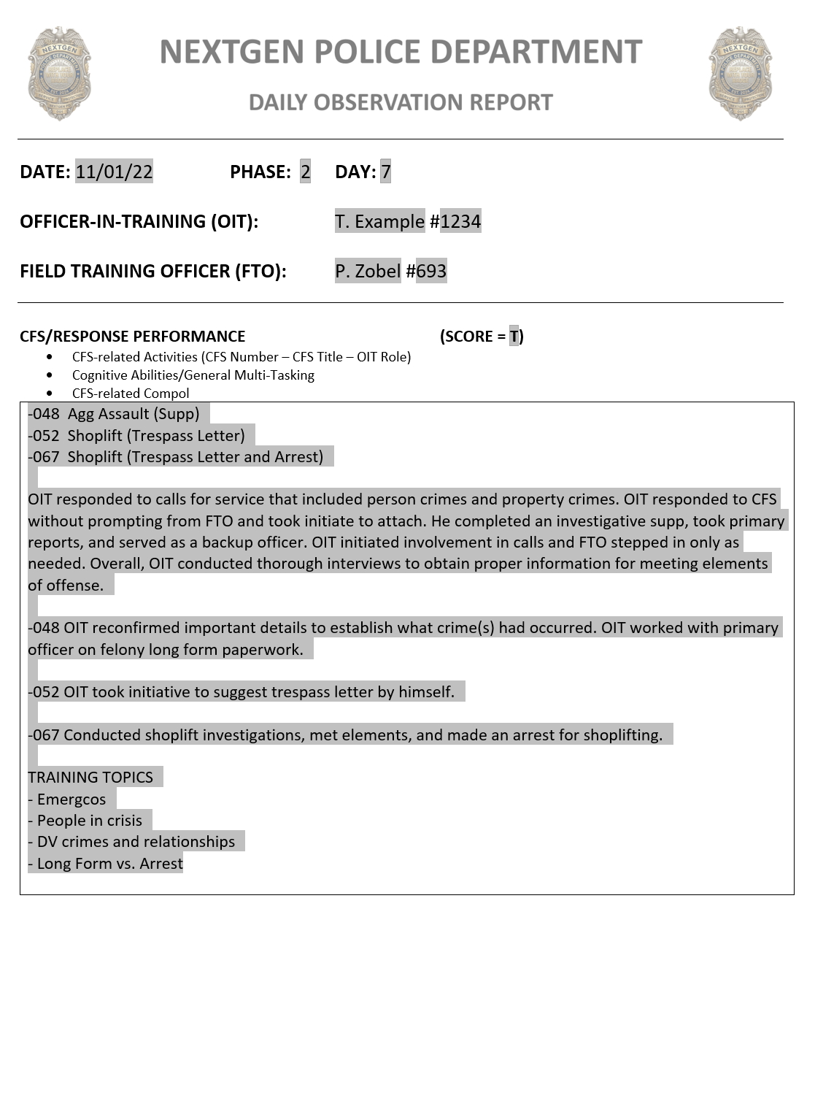
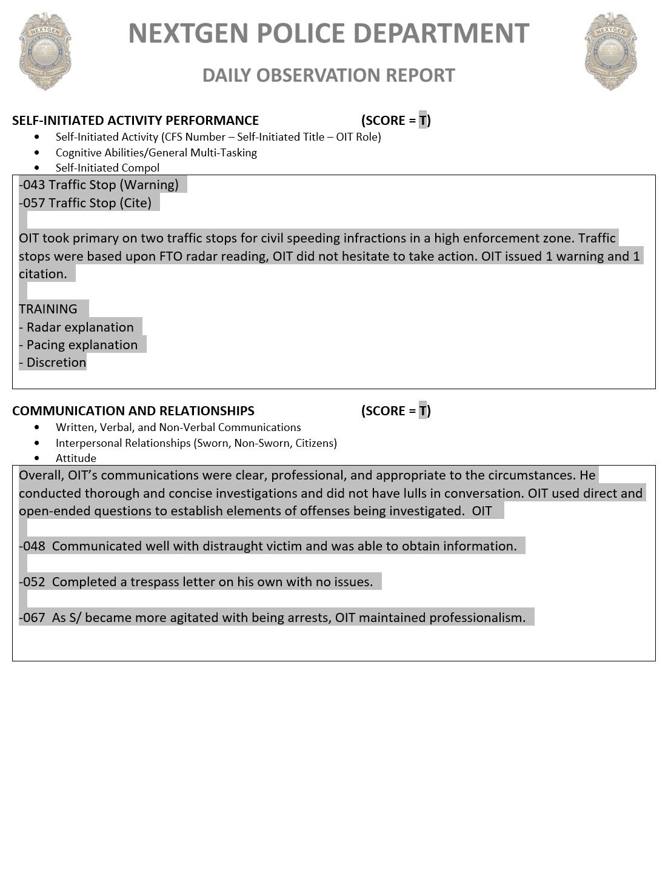

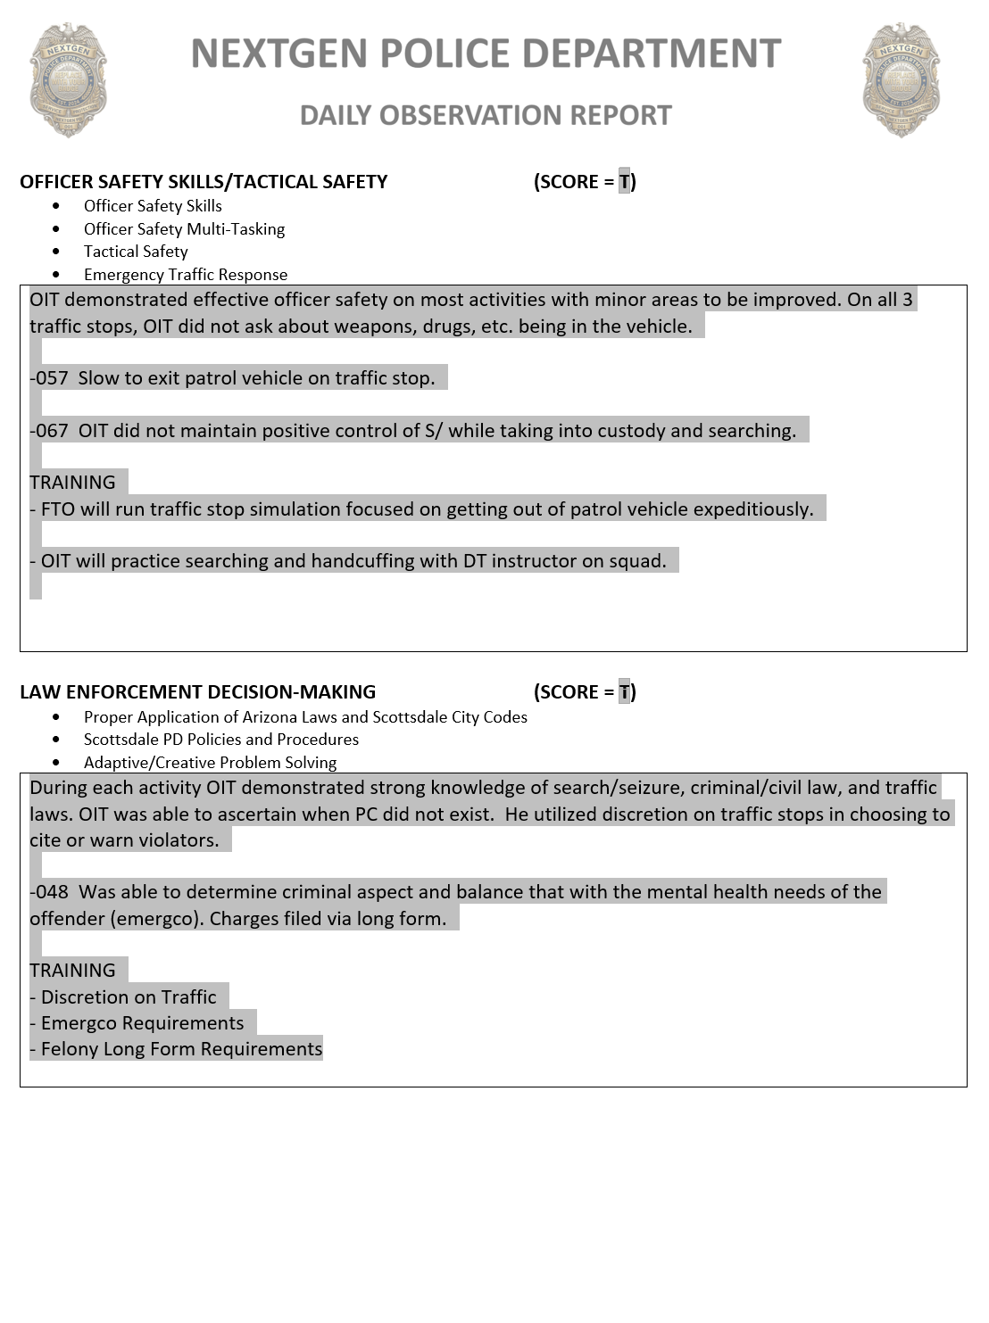
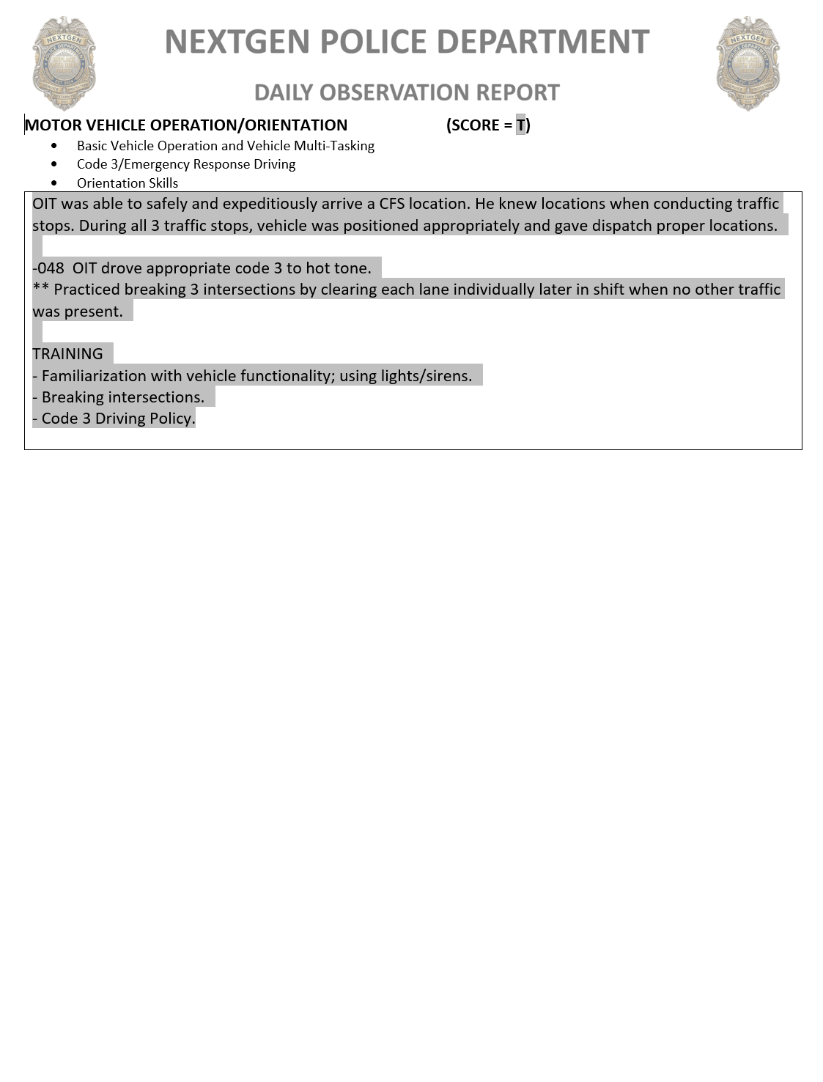

EVALUATION PHASE DAILY OBSERVATION REPORTS:

- Throughout the Evaluation Phases, the OIT is expected to perform as a solo capable officer with the FTO primarily serving as an evaluator.

- There is scoring on Daily Observation Reports (DOR) during Evaluation Phases 4 and 5.

- FTO should still provide training on infrequent tasks the OIT comes across during these phases.

  - If training is provided by the FTO to the OIT during the call for service to get them through it successfully, the DOR scoring will reflect this appropriately.

  - If training is provided by the FTO to the OIT after the call for service to train the OIT and/or improve their performance the next time they experience this type of call, there will be no negative affect to the DOR scoring.

  - If the OIT utilizes other available resources to answer their question(s) and get through the call for service successfully, there will be no negative affect to the DOR scoring.

- A Daily Observation Report (DOR) score will be completed for Standard Evaluation Guidelines Category each shift. As each category is clearly defined, there should be unique documentation in each section. The score is an overall average for that category during that shift.

- DOR Standard Evaluation Guidelines Scoring Rubric (See Page 30 for further.):

  - 5 = Exceeds Standard of a Solo Capable Officer

  - 4 = Solo Capable

  - 3 = Nearly Solo Capable

  - 2 = Not Solo Capable

  - 1 = Unacceptable: Not Solo Capable

- Evaluation Phase Documentation on Daily Observation Reports

  - OIT actions scored a “5” will have appropriate documentation to demonstrate how their actions exceeded the solo capable officer standard.

  - OIT actions scored a “4” should include comments to explain what the OIT did based on the guidelines of the SEGs. If any additional training was provided for the benefit of the OIT, that should be included as well.

  - OIT actions scored a “3, 2, or 1” will have appropriate documentation of the OIT’s actions (what/how/why) along with applicable training provided.

- In an effort to minimize written information the following abbreviations may be used to complete DORs.

OIT - Officer-In-Training FTO - Field Training Officer
P/ - Probationer P/V - Patrol Vehicle
S/ - Suspect S/V - Suspect Vehicle
V/ - Violator V/V - Violator Vehicle
- Additional abbreviations for training techniques are as follows:
F/V - FTO Verbalization BWC/C – Body Worn Camera Coaching
CTQ - Critical Thinking Questions M/R - Mirror Reports
V/T - Verbal Testing RER - Reverse Engineering Reports
D/Q - Debriefing Questions R/P - Role Play
C/D - Commentary Driving D/B - Drive-By
R/R - Role Reversal I/P - Imagine Perfection

DOR STANDARD EVALUATION GUIDELINE QUESTIONS

CFS/Response Performance
- What types of calls for service or community policing activities did the OIT respond to this shift?
- Did they show beat integrity/initiative in responding or did they have to be prompted by FTO?
- What roles/responsibilities did the OIT take on these calls?
- How did the OIT work through problems and identify options, alternatives, or solutions?
- How did the OIT apply the Policing Priorities of Life, Stabilization, Time, and then Apprehension?
- List specific examples that demonstrate solo capability with CFS/Response Performance.
- List specific examples that demonstrate needing improvement with OIT CFS/Response Performance. Are there any patterns of concern developing? (Engagement, Multi-Tasking, Organization, etc.)
- Training Documentation: What training was conducted and/or proficiency tasks covered related to the OIT’s CFS Response Performance during this shift?

Self-Initiated Activity Performance
- What self-initiated or community policing activities did the OIT initiate this shift?
- Did they show initiative in conducting these activities or did they have to be prompted by FTO?
- What roles/responsibilities did the OIT take on these self-initiated activities?
- How did the OIT work through problems and identify options, alternatives, or solutions?
- How did the OIT apply the Policing Priorities of Life, Stabilization, Time, and then Apprehension?
- List specific examples that demonstrate solo capability with conducting self-initiated activity.
- List specific examples that demonstrate needing improvement with OIT Self-Initiated Activity Performance. Are there any patterns of concern developing? (Observing Violations/Suspicious Activity, Engagement, etc.)
- Training Documentation: What training was conducted and/or proficiency tasks covered related to the OIT’s Self-Initiated Activity Response Performance during this shift?

Communication and Relationships
- How were OIT’s communication abilities (written, verbal, and non-verbal) demonstrated during this shift? Were they professional, clear, and appropriate to the circumstances?
- How did the OIT obtain applicable/relevant information on their calls for service? How was their ability to make conversation, conduct interviews, and document information demonstrated?
- Did the OIT complete reports using proper grammar, spelling, and punctuation without errors that compromise clarity of meaning? Were reports and other paperwork submitted in a timely fashion?
- Did OIT complete required administrative activities in a timely manner? (Complete Officer Daily, label BWCs, respond to important emails, do impounds, submit long forms/lab requests, zero check, etc.)
- How were the OIT’s communications via the radio and MDC during the shift?
- How were the OIT’s personal interactions with sworn, non-sworn, and citizens? Did they treat people with dignity and respect without compromising officer safety, good tactics, or appropriate use of force?
- How did the OIT respond to training and/or constructive criticism? Were they open to learning while taking responsibility for their actions, attitude, and effort?
- List specific examples that demonstrate solo capability with Communication and/or Relationships.
- List specific examples that demonstrate needing improvement with Communication and/or Relationships. Are there any patterns of concern developing?
- Training Documentation: What training was conducted and/or proficiency tasks covered related to OIT Communication and/or Relationships during this shift?

Officer Safety Skills/Tactical Safety
- Did the OIT demonstrate basic officer safety skills by:
  - Utilizing officer safety techniques such as distance, cover, concealment, and contact/cover?
  - Recognizing potential threats and demonstrating good situational awareness?
  - Maintaining control of subject movements and placing them in positions of disadvantage, when appropriate?
  - Properly conducting frisks, searches, and/or handcuffing subjects, when appropriate?
  - Not exposing weapons (baton, handgun, TASER, etc.) to potential threats?
  - Keeping their gun hand free during enforcement situations?
  - Maintaining sight of involved parties while conducting police activities?
  - Utilizing the Policing Priorities of Life, Stabilization, Time, and then Apprehension?
- Was OIT able to apply basic officer safety skills and still treat people with dignity and respect?
- How did the OIT use command presence and verbal commands to control, influence, and/or de-escalate?
- How was the OIT’s response to any critical incidents (hot tones) during this shift?
- How did OIT demonstrate understanding of their tactical role and responsibilities when responding to critical incidents (hot tones)?
- List specific examples that demonstrate solo capability with Officer Safety Skills and/or Tactical Safety.
- List specific examples that demonstrate needing improvement with Officer Safety Skills and/or Tactical Safety. Are there any patterns of concern developing? (Critical Task Issues?)
- Training Documentation: What training was conducted and/or proficiency tasks covered related to OIT Officer Safety Skills and/or Tactical Safety during this shift?

Law Enforcement Decision-Making
- How did the OIT demonstrate knowledge of and the ability to apply appropriate actions based upon criminal law, city code, traffic law, and SPD policy/procedure? Was OIT able to solve problems adaptively?
- Was the OIT able to distinguish criminal, non-criminal, and civil activity and make appropriate decisions?
- Did OIT demonstrate understanding of “spirit vs letter” of the law and apply discretion, when appropriate?
- How did the OIT apply the Constitutional Rights of search, seizure, and arrest?
- List specific examples that demonstrate solo capability with Law Enforcement Decision-Making.
- List specific examples that demonstrate needing improvement with Law Enforcement Decision-Making. Are there any patterns of concern developing?
- Training Documentation: What training was conducted and/or proficiency tasks covered related to OIT Law Enforcement Decision-Making during this shift?
Motor Vehicle Operation/Orientation
- Describe OIT’s ability to apply SPD Vehicle Operation Policy while responding to calls for service and/or conducting general patrol operations?
- Describe OIT’s ability to apply SPD Vehicle Operation Policy while responding to critical incidents (hot tones) and/or while driving Code 3 this shift?
- Did OIT ensure equipment was in good working order prior to start of shift?
- Did OIT search backseat before/after shift and after transporting subjects?
- How did OIT demonstrate knowledge of major streets, intersections, locations, hundred block numbering sequence, and patrol area boundaries?
- Was OIT able to arrive at locations in a timely manner, with or without the use of maps?
- Was OIT consistently aware of their current location?
- List specific examples that demonstrate solo capability with Motor Vehicle Operation and/or Orientation.
- List specific examples that demonstrate areas of improvement with Motor Vehicle Operation and/or Orientation. Are there any patterns of concern developing?
- Training Documentation: What training was conducted and/or proficiency tasks covered related to OIT Motor Vehicle Operation and/or Orientation during this shift?

FIELD TRAINING SUPERVISOR EXPECTATIONS

SERGEANT EXPECTATIONS:

- Be engaged with Field Training Officers and any assigned OITs.

  - Work with FTO to be purposeful in their training for the OIT and develop a plan each shift.

  - Meet with FTO and OIT regularly throughout the work week and check-in on calls for service. Share your observations and feedback with the FTO and OIT.

  - Recognize that getting an OIT the training they require is the priority. Therefore, an FTO’s statistical production may be less than it would normally be during times they have an OIT. They also may need to go to other districts to get required training experiences for the OIT.

- Review the Daily Observation Reports.

  - If something does not look right or you notice a pattern developing with an OIT, be sure to discuss it with the FTO.

  - A sergeant’s observations and feedback may be included in a DOR when brought to the FTO’s attention.

- Participate in Phase Board Meetings.

  - Preferably both the outgoing and incoming sergeants participate in Phase Board Meetings. If both cannot attend, the incoming sergeant should be at the Phase Board.

  - Check that the Field Training Workbook, DOR’s, and other administrative tasks are up to date.

  - Sergeants should discuss any specific squad expectations they have at the Phase Board.

- Serve as the “eyes and ears” of the Field Training Staff.

  - Advise Field Training Staff of any training issues or concerns.

  - Verify FTOs are meeting the expectation to get OIT’s as much exposure as possible to a wide variety of calls for service.

  - Verify FTOs are providing training outside of their own comfort zones. (Example: An FTO that likes traffic is doing more than just traffic related activities.)

- Administrative Tasks
  - Keep the same documentation you would for any of your officers during an OIT’s Solo Evaluation Pahse.
  - Complete the Release from Field Training Form after the Solo Evaluation Phase.

EXTENSION PLANS

KEY CONCEPTS OF EXTENSION PLANS:

- EXTENSION PLAN: An Extension Plan is utilized when the FTO deems that an OIT needs to stay in their current phase to get more exposure to Proficiency Tasks due to illness, family emergency, military leave, approved vacation for critical obligations, or low CFS volume. This can take place in either a Training or Evaluation Phase.

- An Extension Plan can be for 1 or 2 weeks depending on the circumstances and time missed.

- Extension Plans for low CFS volume are primarily reserved for Phases 3, 4, or 5.

- An Extension Plan may be utilized at the end of Phase 3 if the OIT needs additional time to complete the required Proficiency Tasks or get additional experience prior to the Evaluation Phases. This is not a negative against the OIT.

- An Extension Plan may also be utilized during either of the Evaluation Phases when the OIT did not receive enough activity exposure and the FTO needs more time to properly evaluate the OIT.

  - This will allow the OIT more time to demonstrate solo capability to the FTO evaluator.

  - At the end of the Extension Plan, the FTO will decide to pass/fail the OIT on that Evaluation Phase.

- To initiate an Extension Plan, the FTO will contact the Field Training Staff to advise of following:

  - Reason for the Extension Plan

  - Length of the Extension Plan

  - The reason and length of the Extension Plan will be documented in the next shift’s DOR.

  - There is no Extension Plan form, simply contact the Field Training Staff via phone or email as soon as the FTO believes an Extension Plan is necessary to make arrangements.

- Extension plans should be used sparingly and only for these specific circumstances.

- It is the responsibility of the FTO to do everything possible to get the OIT as much training and exposure to Proficiency Training Topics as they can in the assigned amount of time for that phase.

PERFORMANCE TRAINING PLANS

KEY CONCEPTS OF PERFORMANCE TRAINING PLANS:

- PERFORMANCE TRAINING PLAN: Replaces what was formerly known as a Remedial Training Plan. Performance Training Plans are only created when an OIT is demonstrating repeated difficulty applying any of the Critical Tasks or significant SEG issues that would prevent the OIT from being a successful solo capable officer.

- If an OIT is having significant difficulty in any of the Critical Tasks, a 2-week Performance Training Plan may be developed by the FTO and Field Training Staff to address the specific issue(s).

- When writing a Performance Training Plan, the FTO is responsible for providing specific examples from DORs to the Field Training Staff of each identified Critical Task issue. The Field Training Staff will then work in conjunction with the FTO to write the Performance Training Plan.

- Critical Tasks include:
  - Officer Safety
  - Use of Force
  - Engagement
  - Search/Seizure
  - Multi-tasking

- A Performance Training Plan is essentially a “pause” in the OIT’s progress to allow time to focus specifically on the identified Critical Task(s) they are having an issue with.

- OITs are expected to continue working on getting exposure to Proficiency Tasks during this time, but the primary focus is improving Critical Task Performance.

- An OIT may receive up to 2 Performance Training Plans total in the Training Phases to provide them more time to demonstrate proficiency in the identified Critical Task(s).

- An OIT in Evaluation Phases 4, 5, and Solo may only receive 1 Performance Training Plan total before continuing to the next Evaluation Phase.

- If there is no improvement after initiating a Performance Training Plan, the OIT may be referred to the Field Training Review Committee.

- A member of the Field Training Staff will be present for all Performance Training Plan Meetings.

- Signed copies of any Performance Training Plans will be added to the appropriate phase section of the Field Training Workbook or attached to a DOR in the FTO Software.

- Example of a Performance Training Plan Form:

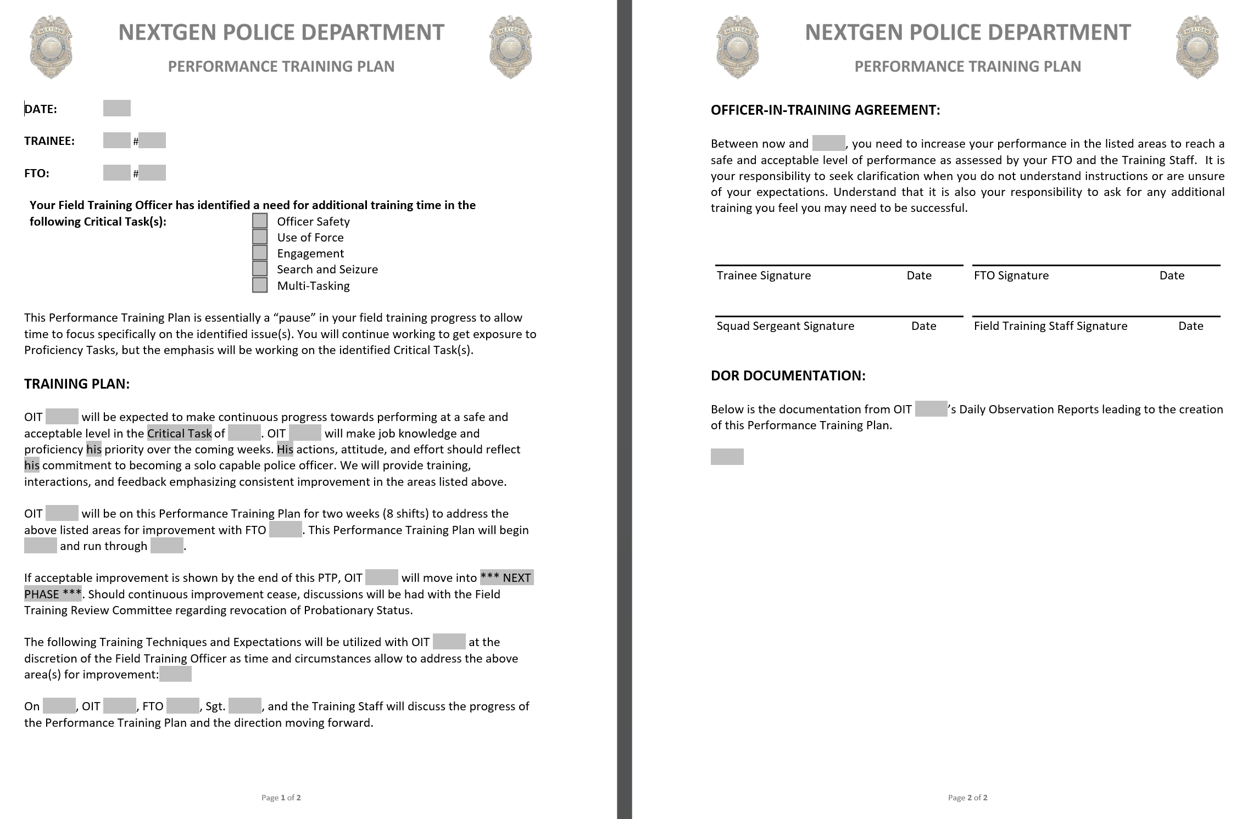

FIELD TRAINING REVIEW COMMITTEE

KEY CONCEPTS OF THE FIELD TRAINING REVIEW COMMITTEE:

- The Field Training Review Committee consists of the department’s Field Training Program Chain of Command from the FTO Staff up to the Chief of Police.

- The purpose of this committee is to advise the Chief or assigned leader on an OIT’s field training status and provide a recommendation on the OIT’s future with the department. Options include:

  - Provide additional training through a Performance Training Plan

  - Probationary Rejection

  - Support for offering a more suitable alternative position within the department. (if available)

- This recommendation is based upon the answers to the following questions after reviewing the Field Training Workbook, Performance Training Plan(s), and Daily Observation Reports:

  - Is the OIT showing positive progress in their learning of Critical Tasks and will continued training get them to a solo capable level?

  - Did proper training get delivered by the FTOs?

  - Did the FTOs follow proper policy, procedures, and guidelines with the training they provided?

  - Does the field training documentation support fair and accurate training, feedback, and evaluations given to the OIT?

- The Chief or assigned leader then makes the decision on the OIT’s status.

TRAINING TECHNIQUES

KEY CONCEPTS OF TRAINING TECHNIQUES:

- The Nextgen Field Training Model is based on the concept of proactive and directed training that results in an officer who is qualified for solo patrol.

- This training program uses a variety of techniques to address the different learning styles and needs of adult learners.

- FTOs should document all training activities done with the OIT in the Daily Observation Report.

  - For the best outcome, Proficiency Tasks should be instructed utilizing the crawl, walk, run experiential learning philosophy. These training activities make for good crawl and walk training options.

- Below is a list of a variety of training techniques. FTOs should be familiar with these training options and utilize them whenever they may benefit the OIT’s learning.

- NO COST QUIZ - A No Cost Quiz is a simple way to make the OIT use effortful retrieval to think about knowledge, skills, or experiences they have been taught during a previously to assist in building their mental connection to that information. These can take place before/after briefing, during a slow point in a shift, or at the end of a shift. The FTO provides the OIT with a short 3 to 10 question quiz that asks questions specific to information they have previously trained. Some example questions are below:
  - Name the three Title 28 violations you can enforce while on private property.
  - Name the 3 most important things you learned from our last shift.
  - Yesterday, we put together a county long form. Name as many of the required documents as you can remember.
  - List the addresses or major cross streets for the following strategic locations in our beat.

- BRIEFING TRAINING OUTLINE – Briefing Training Outlines are best used when the FTO wants to teach or reinforce a specific topic of knowledge. Ask the OIT to write an outline for presenting a 10 – 15 minute briefing training to the squad. Ask for them to do as much as possible from memory before referring to other resources for additional information. This will force effortful retrieval of information and then promote the utilization of resources. This activity provides the FTO a good idea of what the OIT knows about the topic. Once the OIT is done, additional probing questions should be asked by the FTO to determine the OIT’s level of understanding. Whether the OIT actually presents the information in briefing is up to the FTO and the Sergeant. Some example topics are below:
  - Contact Types (Consent, Investigative Detention, and In-Custody)
  - Code 3 Driving
  - Proper Searching of Suspects
  - Graham vs. Connor
  - Proper Unloading Procedure for a Pistol
  - Standardized Field Sobriety Test

- SEARCH TRAINING – Search training is an activity best utilized with an OIT struggling with completing effective and thorough searches. This training activity requires the usage of a person in regular street attire with a willingness to be searched. FTO will need a collection of items the person being searched may or may not hide on themself such as a handcuff key, blue gun, plastic knife, fake drugs, broken pen, etc. After the person hides 0, 1, 2, or 3 items on their person, have the OIT conduct a search on them. When they believe they are done with the search and have located any and all items, have the OIT declare the person is safe. Then debrief the OIT’s search procedure and results.

- BWC/BWC COACHING - FTO reviews their BWC or OIT’s BWC footage with an experience that has specific coaching points FTO it looking to repeat and/or recognize. They discuss different perspectives of the scene based on whose footage is being reviewed. FTO can discuss relevant elements such as tactical positioning, command presence, interview questions, evidence collection, decision-making, application of the Policing Priorities, etc. This can be utilized with the Role Reversal Activity to give the OIT an opportunity to debrief actions they observed as their FTO handles the call.

- QUICK REACTION DRILLS – Short and Simple Scenarios to train an OITs ability to quick decide between making urgent decisions and patient decisions. Create a quick reaction drill that can be utilized with new officers. (Urgent / Patient / Traffic / Search & Seizure)

QUICK REACTION DRILL:

SETUP:

PURPOSE:

OBJECTIVES:

- IMAGINE PERFECTION - FTO has the OIT imagine the perfect traffic stop, shoplifting call, DV call, DUI investigation, etc. Once the OIT has imaged this perfect call for service or self-initiated activity, have them write out the process for handling that situation perfectly in 10 - 15 steps. Limit the number of steps so that the OIT is focusing on only the most important aspects of handling the situation they are thinking about. Once complete, FTO debriefs OIT’s steps and draws comparisons to OIT’s performance on previous similar calls for service. This is an excellent training technique to generate effortful retrieval, reflection, and positive imagery of the OIT handling a situation correctly. This technique is especially useful for OITs that are having difficulty remembering repeatable processes or forgetting key steps when under stress during real-world situations. Imagine Perfection also helps set a baseline that helps the OIT more easily identify when a situation may be going array.

- PATROL BINGO – Utilize a blank Bingo Card template and fill in a variety of call for service types or other policing activities for the OIT to focus on trying to obtain during their training time for that phase. If they get a “bingo” or a “blackout” in the phase, have an idea of a way to recognize and reinforce their efforts. This is a great way to promote pro-active policing and also to assist OITs in learning to get involved in their own learning.

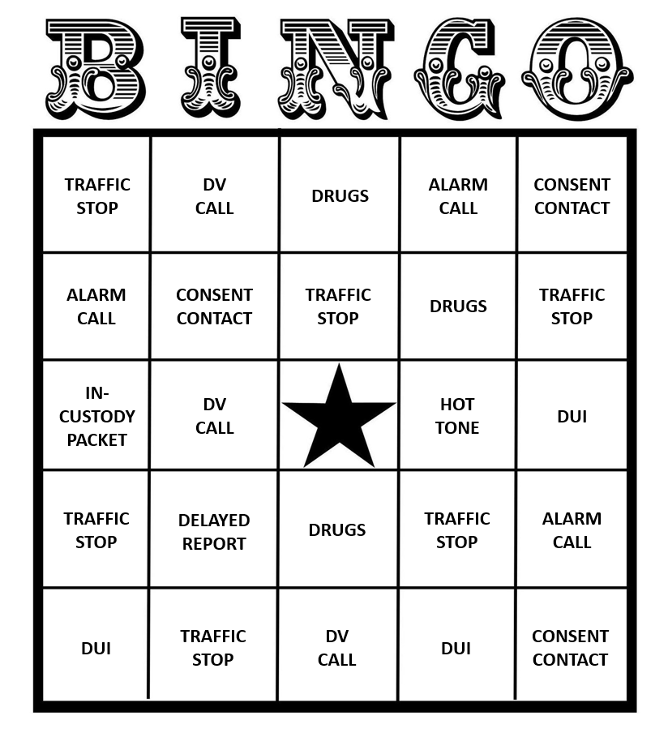

- COMMENTARY DRIVING - Commentary driving is used to enhance the OIT’s situational awareness, ability to multi-task, diagnose knowledge of police related activity, and address geographic knowledge. This technique allows the FTO to “see” what the OIT “sees.” This further allows the FTO to know if the OIT recognizes criminal activity and what their thought process is in approaching the observation. The OIT and FTO may take turns providing commentary driving throughout the shift. The FTO may demonstrate more in the beginning and less later on as the OIT begins to understand the concept and goals. This process relates back to the Situational Awareness Loop in the P-R-I-D-E Adaptive Decision-Making Model:

  - PREDICT
    - Observe the environment and describe it verbally.
    - Make predictions about the type(s) of criminal activity that may be observed.
    - Make predictions about how to handle a situation if it occurred at this second.
  - REACT
    - Is any of the criminal activity predicted currently observable?
    - Is there anything drawing attention by being out of place?
    - If “yes” to the above questions, start making decisions to handle it.
    - If “no” to the above questions, continue to Evaluate.

  - EVALUATE
    - Evaluate the Predictions and Reactions made and verbalized.
    - If that information is sound, continue with this process.
    - If that information is incorrect or changes, adjust and Predict again.

- ROLE REVERSAL - The OIT and FTO switch roles for a call for service or designated period of time during the shift. This should be done to demonstrate usage of Critical Task abilities, how to conduct an investigation, handle an incident, etc. This can also be used to diagnose training needs and feedback styles of the OIT, confirm the OIT’s mastery of a task, and to acknowledge that experienced officers can still learn from others.

- MIRROR INVESTIGATIONS/REPORTS/CITATIONS – With the FTO acting as the primary officer, the OIT shadows the FTO as they conduct an investigation, write a report, and/or complete a citation. The OIT should be taking their own notes throughout these processes. While the FTO completes the investigation, the OIT will complete their own work. After both are finished, they will compare their final work products and go over the things that are the same and are different.

- REVERSE ENGINEERING REPORTS – In an effort to better learn the investigative process, the OIT will read an existing report (preferably from a detailed quality investigator). They will write their own investigative notes from what they believe the important details are that are contained within the report and are necessary to articulate all the elements of the crime. After allowing some time to pass (spacing), have the OIT rewrite the report only using the notes taken from the original report. This will not only teach them how to structure their reports, but will give them guidance on bettering their investigative skills and identifying information.

- DRIVE-BY - Use the actions of other officers and other calls for service as a learning opportunity. Rather than investigating the incident directly, the FTO and OIT arrive as extras at the scene. They should take this opportunity to walk through the investigation as if they were the primary unit, but also observe what others are doing. FTO should introduce the OIT to other officers (patrol, canine, traffic, bike patrol), CSS, detectives, etc. Have OIT utilize these resources to obtain a different perspective of the scene or learn relevant details they might not have known about.

DEBRIEFING OPTIONS

FIELD TRAINING DEBRIEFS

- Debriefing after each call for service or self-initiated activity is key to learning.

- #1 Rule of Field Training – Make trainees make decisions. OITs need to be making decisions so that you are evaluating their decisions, not the FTO’s.

- Debriefing facilitates the following learning concepts:
  - Interleaving
  - Effortful Retrieval
  - Spacing
  - Mental Repetitions
  - Many Others

- Effective Debriefing Simplified
  - FTO asks a question.
  - FTO shuts up and listens.
  - OIT talks.
  - FTO comments or asks directed questions.
  - Then repeat until the event is covered.

- When debriefing, it is vital to utilize the 3 R’s: Repeat, Recognize, and Reinforce.

- Debriefing is the best way to facilitate the Experiential Learning Cycle.

DEBRIEFING OPTIONS: There are many options available to assist field trainers with debriefing calls for service, self-initiated activities, and OIT decision-making in a more purposeful and effective manner.

- CHRONOLOGICAL DEBRIEF – In chronological order, have the OIT identify the most important 3 to 5 decision-points of the call for service. As they do, ask questions related to those decision-points to bring out the good things they did and the areas for improvement.

- LAYERED CHRONOLOGICAL DEBRIEF
  - OIT gives a chronological play-by-play of what they recall from the incident without FTO comment or opinion.
  - OIT then goes through the same event in chronological order discussing the positive actions they took.
  - OIT goes through the incident chronologically recalling areas for improvement.
  - During each piece of this debrief, the FTO can ask directed questions to get to information they want to discuss further.
- P-R-I-D-E MODEL DEBRIEF - Utilize the P-R-I-D-E Adaptive Decision-Making Model to ask questions of the OIT in the order of the model: Predict, React, Investigate, Decide, and Evaluate. This can be done for a single call for service, self-initiated activity, or a specific decision. Asking OITs questions in this order assists them in thinking through the event or decision in the same manner in which the brain processed it.

- CRITICAL THINKING QUESTIONS - This debriefing method begins while enroute to an event, continues throughout the event, and then at the conclusion of the event to develop alternative scenarios for the OIT to learn from. These questions are designed to get the OIT to start thinking about taking deliberate action with their decision-making.
  - If/When/Then (Pre)
  - What?
  - How?
  - Why?
  - If/When/Then (Post)

- JUSTIFICATION DEBRIEF - Have the OIT identify the key decision points that were made during a particular call for service or self-initiated activity. Ask them to justify “why” they did or did not make certain decisions by utilizing law, policy, procedure, and/or or the Policing Priorities.

- START, STOP, CONTINUE, CHANGE - This is a simple set of four questions meant to assist the OIT in identifying what they are doing well and where they can improve.
  - What would you like to START doing?
  - What should you STOP doing?
  - What would you like to CONTINUE doing?
  - What should you CHANGE?

- STANDARD EVALUATION GUIDELINES DEBRIEF - Ask the OIT to describe their performance based upon their actions, attitude, and effort on an event in each applicable Standard Evaluation Guideline Category used by your agency.
  - CFS/Response Performance
  - Self-Initiated Activity Performance
  - Communication and Relationships
  - Officer Safety Skills/Tactical Safety
  - Law Enforcement Decision-Making
  - Motor Vehicle Operation/Orientation
